#### ****Experiment 1: LAN Configuration Using Straight-Through Cables**** and Cross-Over Cables

* **Objective:** To set up a basic LAN using straight-through cables.
* **Tools/Hardware:** Straight-through Ethernet cables, switch, routers, PCs, RJ-45 connector.
* **Tasks:**
  1. Connect devices using straight-through cables.
  2. Assign IP addresses manually or via DHCP.
  3. Test network connectivity using ping.

**Theory of LAN Configuration Using Straight-Through and Cross-Over Cables**

In a Local Area Network (LAN) configuration, communication between devices is established using Ethernet cables. Two common types of cables are **Straight-Through cables** and **Cross-Over cables**. Each type has specific use cases based on the devices being connected.

**1. Straight-Through Cables**

A Straight-Through cable is the most commonly used Ethernet cable for connecting devices that are different in type, such as a computer to a switch or a router. The wiring on both ends of the cable follows the same standard, either **T568A** or **T568B**.

**Pin Configuration for Straight-Through Cable**

The pin assignments are identical at both ends of the cable:

* **T568B Standard:**
  + Pin 1: Orange-White
  + Pin 2: Orange
  + Pin 3: Green-White
  + Pin 6: Green
  + Pins 4, 5, 7, 8: Blue, Blue-White, Brown, Brown-White
* **T568A Standard:**
  + Pin 1: Green-White
  + Pin 2: Green
  + Pin 3: Orange-White
  + Pin 6: Orange
  + Pins 4, 5, 7, 8: Blue, Blue-White, Brown, Brown-White

**Use Cases**

* **Computer to Switch**
* **Router to Switch**
* **Computer to Router**

This cable type ensures proper communication by aligning the transmitting (Tx) and receiving (Rx) pins with the corresponding counterparts on the connected devices.

**2. Cross-Over Cables**

A Cross-Over cable is used to connect two devices of the same type directly, such as two computers or two switches. In this configuration, the transmit and receive pins are crossed to enable communication.

**Pin Configuration for Cross-Over Cable**

One end follows the **T568A standard**, while the other follows the **T568B standard**:

* **T568A End:**
  + Pin 1: Green-White
  + Pin 2: Green
  + Pin 3: Orange-White
  + Pin 6: Orange
* **T568B End:**
  + Pin 1: Orange-White
  + Pin 2: Orange
  + Pin 3: Green-White
  + Pin 6: Green

**Use Cases**

* **Computer to Computer**
* **Switch to Switch**
* **Router to Router**
* **Computer to Access Point (AP)** (if AP is not uplink-aware)

The crossing of Tx and Rx pins allows two devices with identical signal transmission modes to communicate.

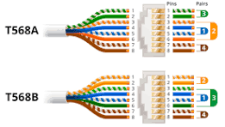

**…………………………………………………………………………………………………..**

When we configure a single laptop to run **Windows 10** and **Windows Server** on separate partitions, this is called **Dual-Booting**.

### ****Definition of Dual-Booting****

**Dual-Booting** refers to the process of installing and using two (or more) operating systems on the same computer. The system provides an option to choose which operating system to boot into during startup. Each operating system resides on its own partition of the hard drive.

**Steps to Configure Dual-Boot on a Laptop**

**Prerequisites**

* A laptop with sufficient resources (CPU, RAM, and storage).
* A partitioned hard drive or unallocated space for the second operating system.
* Installation media for both operating systems (e.g., bootable USBs or DVDs for Windows 10 and Windows Server).
* A backup of important data in case of errors.

***For generating space for Windows Server we have to allocate a specific space.***

1. At first check in which drive we have enough free space from **This PC** from our computer device.
2. Then go to the **Computer Management** by searching from **Search Bar**.
3. After reaching in **Computer Management** we can see **Storage** wehere stays **Disk Management.**

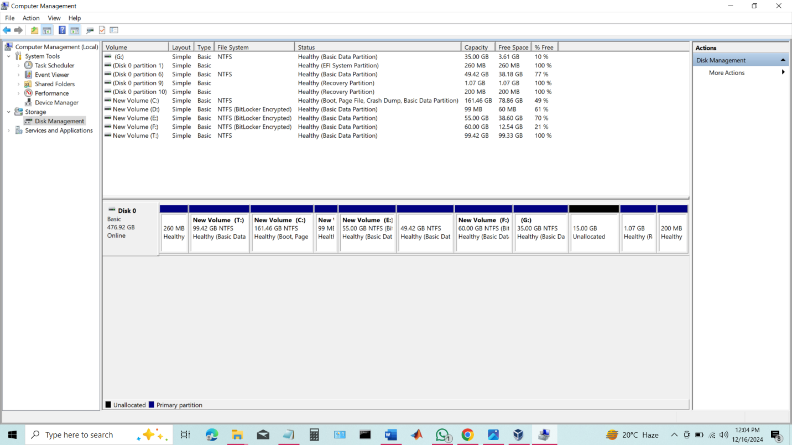

1. Then select **Shrink Volume.**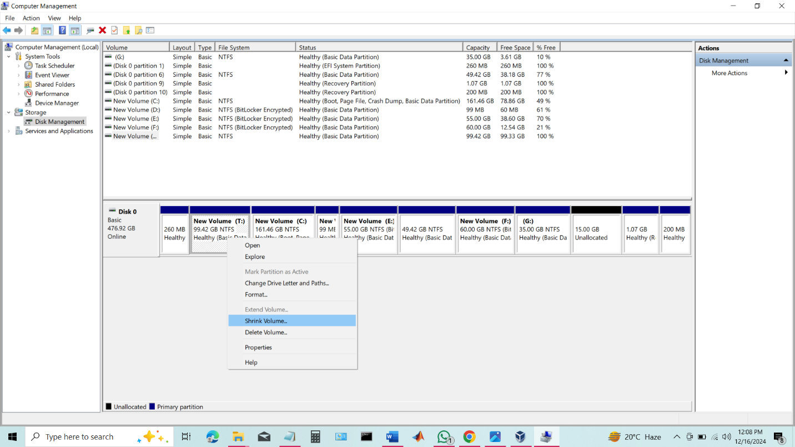
2. After clicking it select how many Gigabyte of data we want suppose we are taking here 35 Gb then we need 35*1024=35840 Mb (Because here only shows Mb not direct Gb).

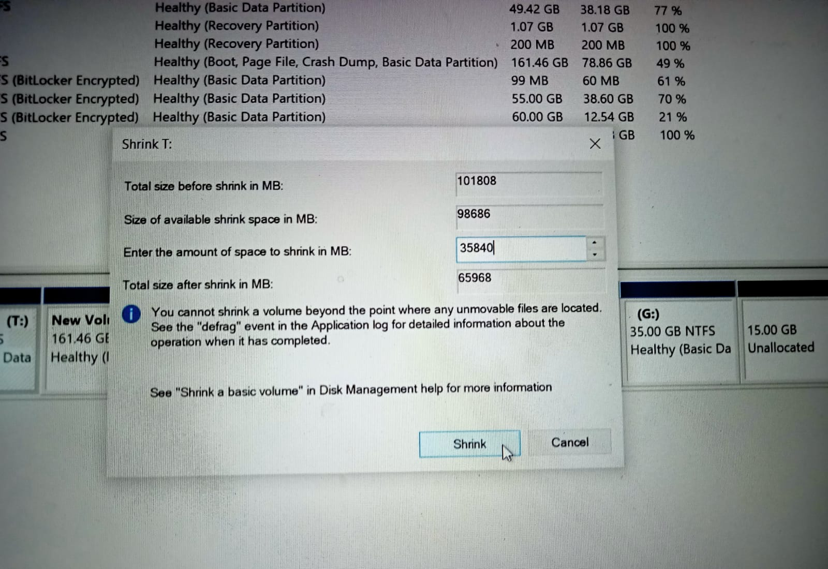

1. Now right-click on the new unlocated new space and select **New Simple Volume.**
2. Then it will come **New Simple Volume Wizard** with some pages for naming and configuring space. Click “**Next”** all the things and choose a letter which we want to name for the new volume space.

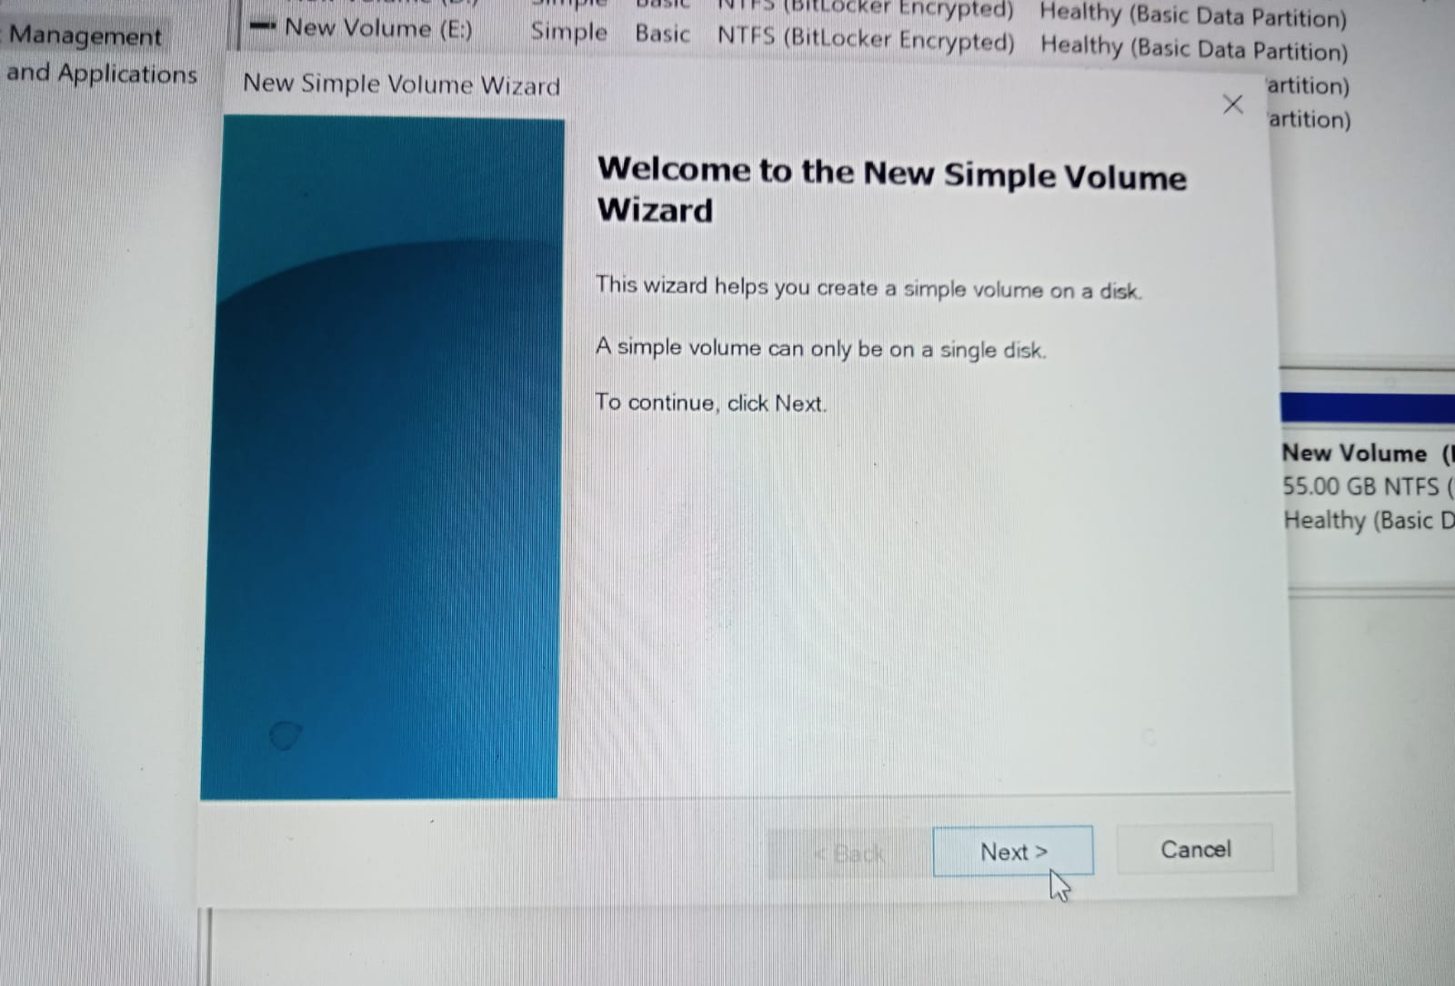

1. Finally press **Finish** to complete it.

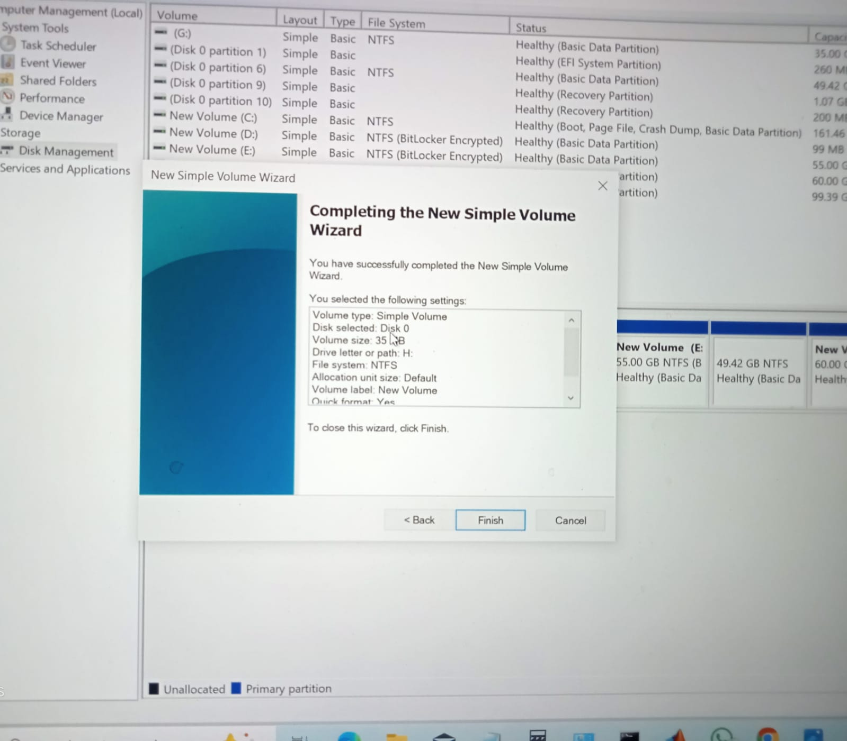

**For installing Windows Server we need a bootable Pen drive in GPT disk.**

**Steps are given below:**

* 1. At first we need the GUID Partition Table (GPT) was introduced as part of the Unified Extensible Firmware Interface (UEFI) initiative. GPT provides a more flexible mechanism for partitioning disks than the older Master Boot Record (MBR) partitioning scheme that was common to PCs. We need GPT form for our suitable computer device. If our device supports MBR then we have to take another actions.
  2. Put the **bootable Pen drive** in our **computer device** and restart the device and continuously press **BIOS** Key (**F2 key** as my **ASUS** device it is my **BIOS** key).
  3. Now it will come like this. Now click on **Boot Menu.**

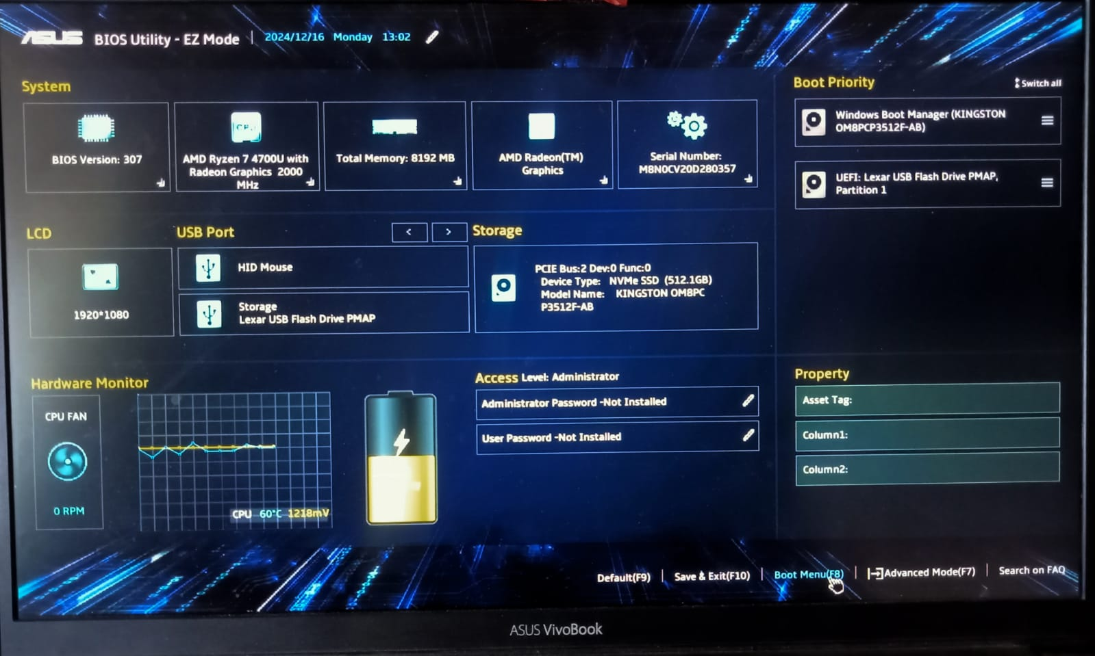

* 1. Now select **UEFI: Lexar USB Flash Drive PAMP, Partition 1**.

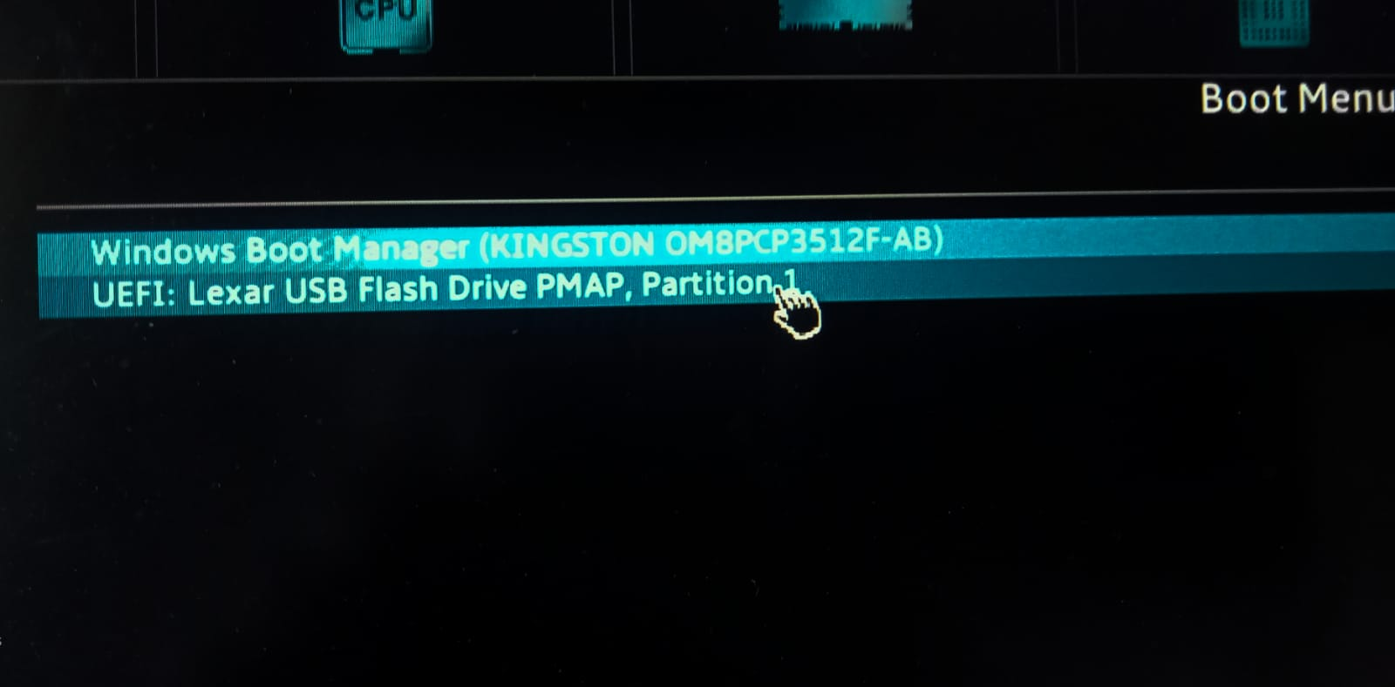5. Now when Windows Server installation will be start. Click on **Next.** After that click on **Install now.**

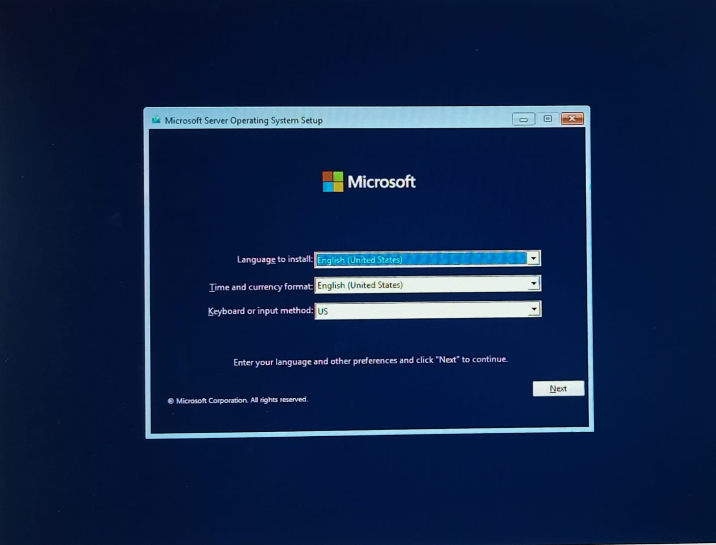

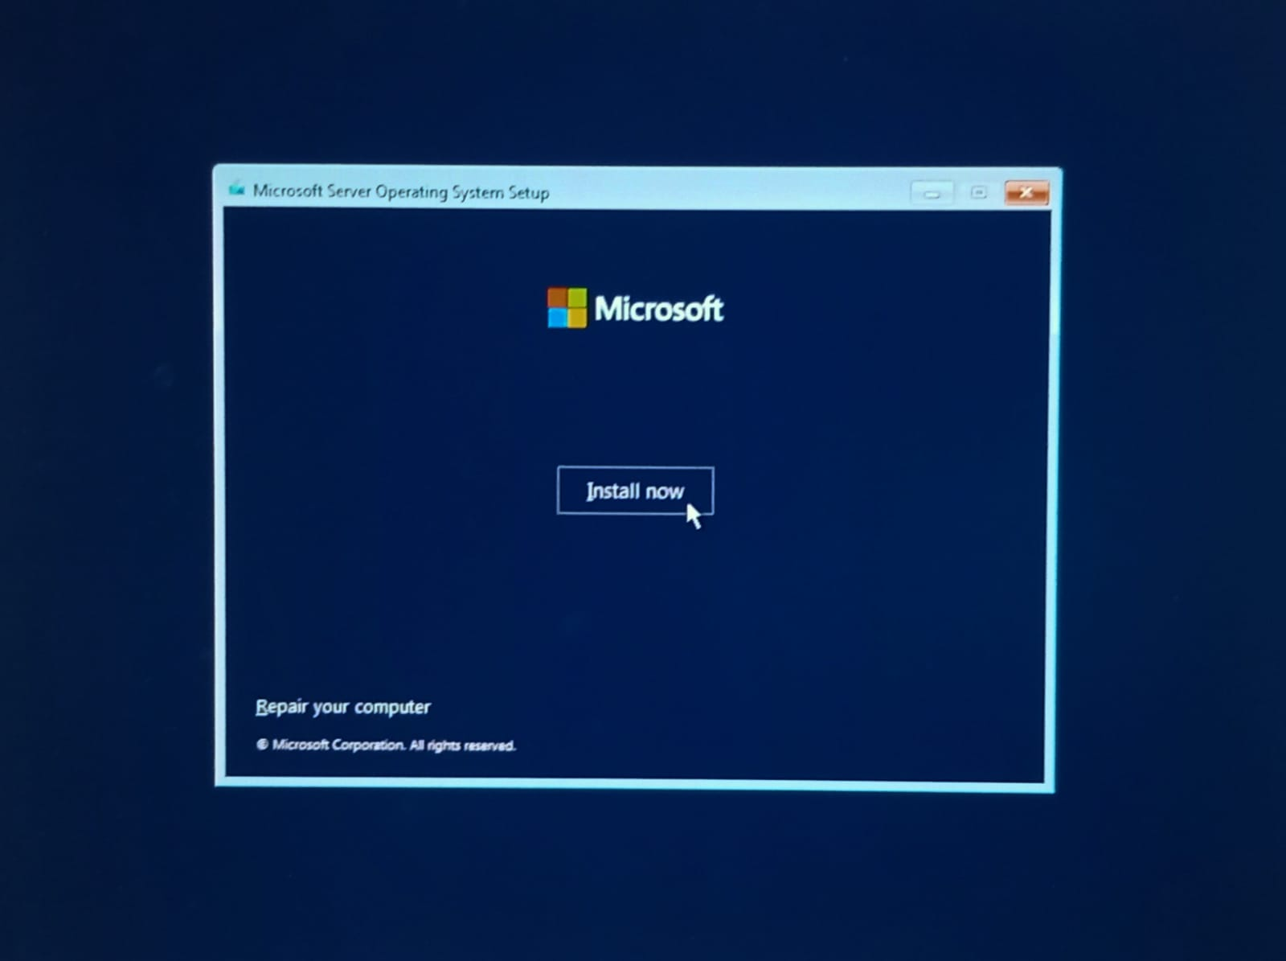 6. Now select **I don’t have a product key.**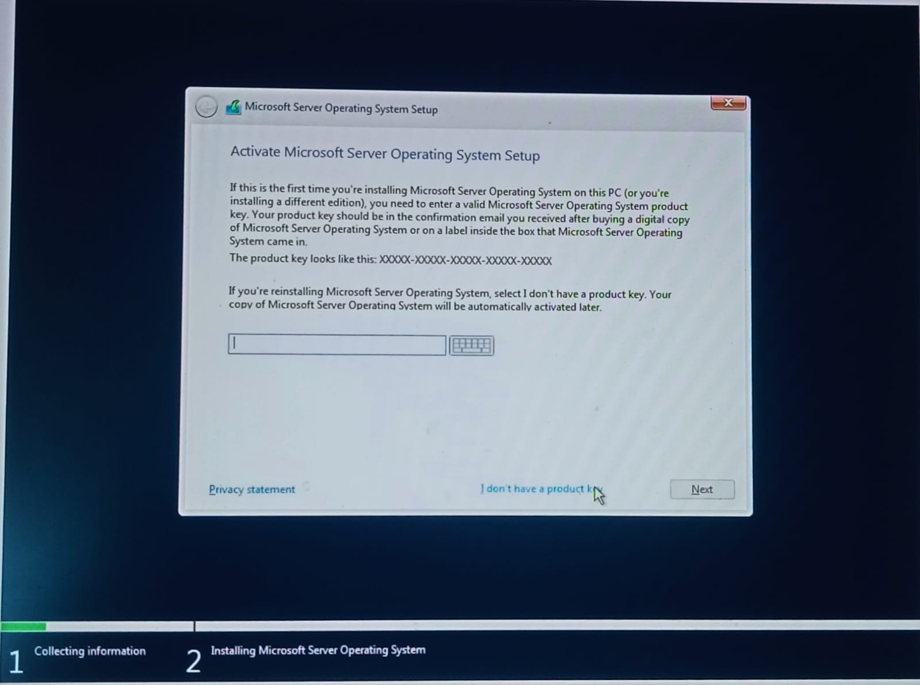7. Now select on **Windows Server 2022 Standard (Desktop Experience) and** then **click on Next**.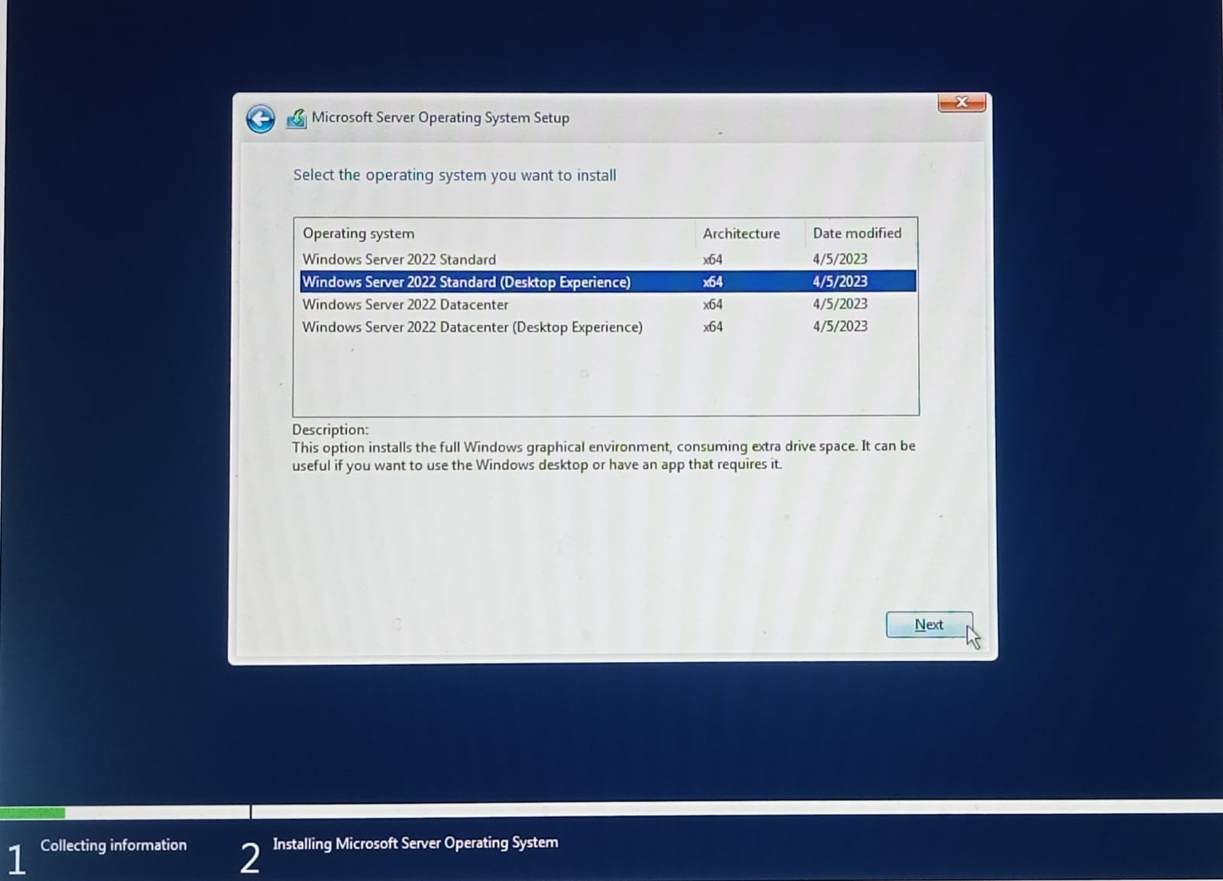

* + 1. Select the box **I accept…** and then click on **Next.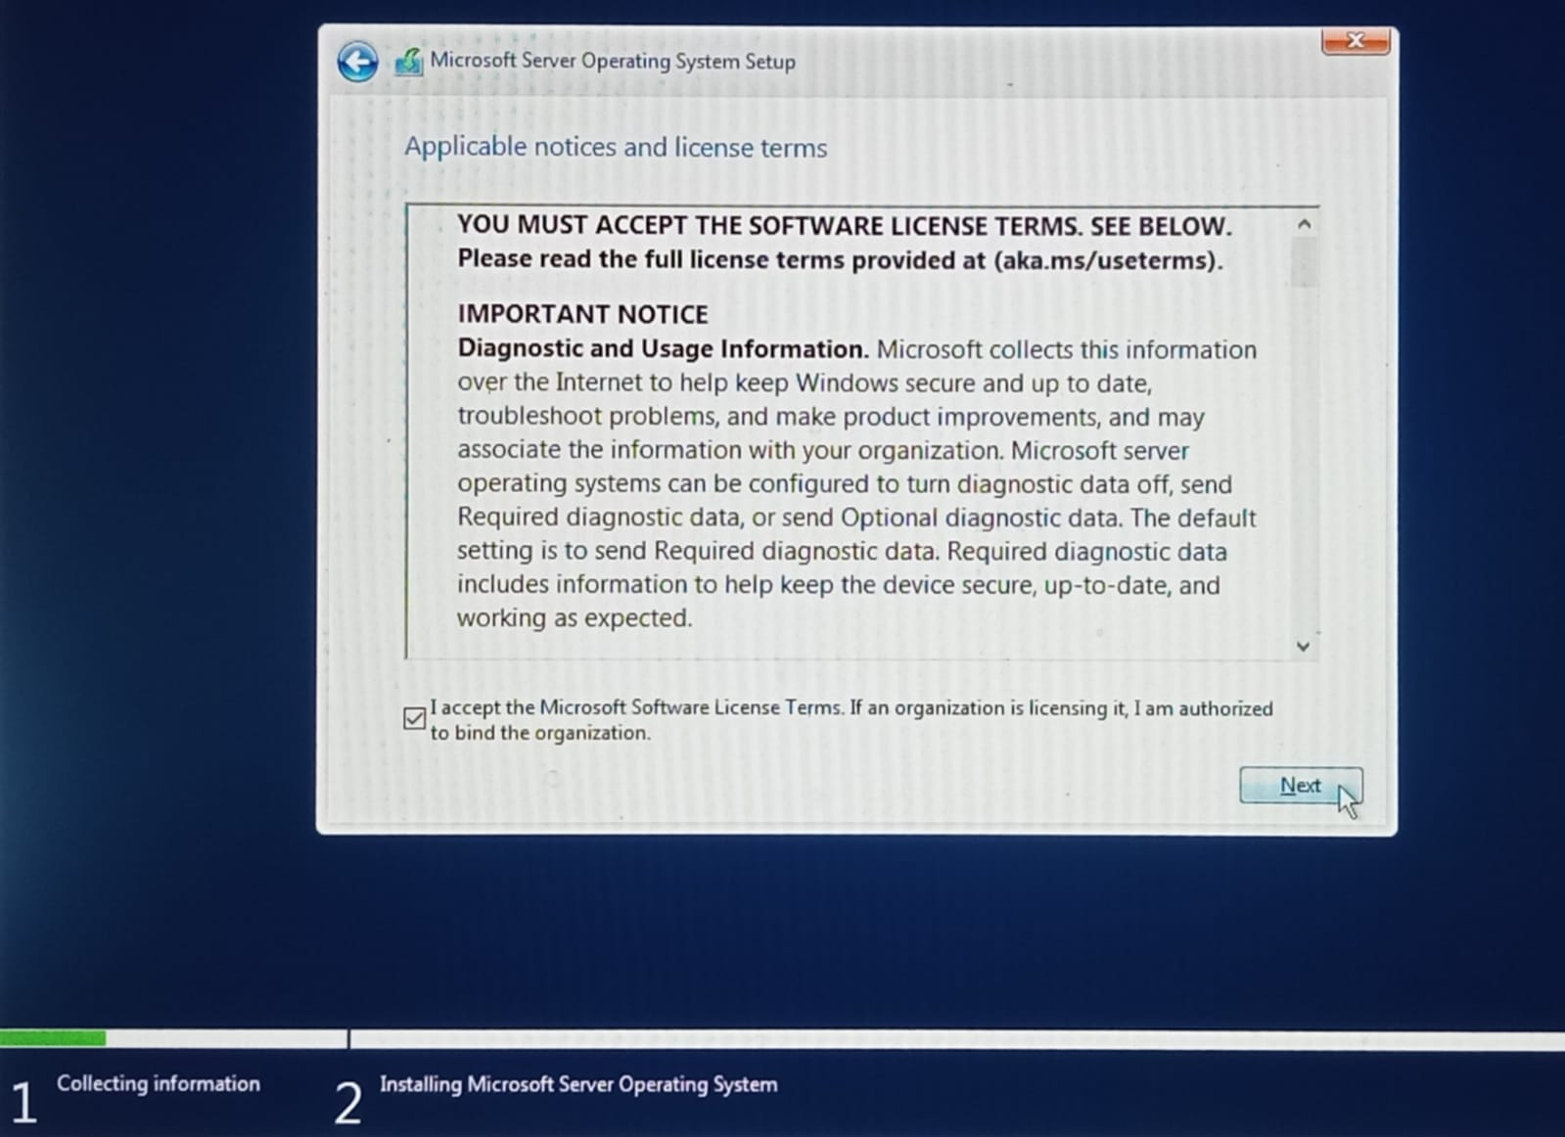9.** Now select **Custom: Install Microsoft Server OS only (advance).**

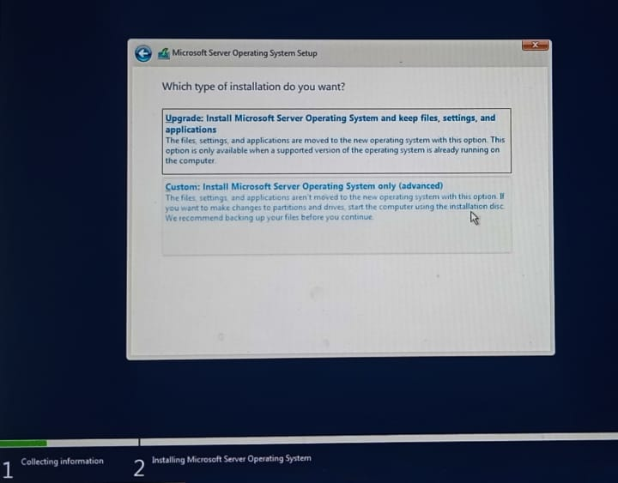

10. I have selected 20GB space for utilizing my drive space. All the above things are same but except of 35 Gb I selected 20 Gb.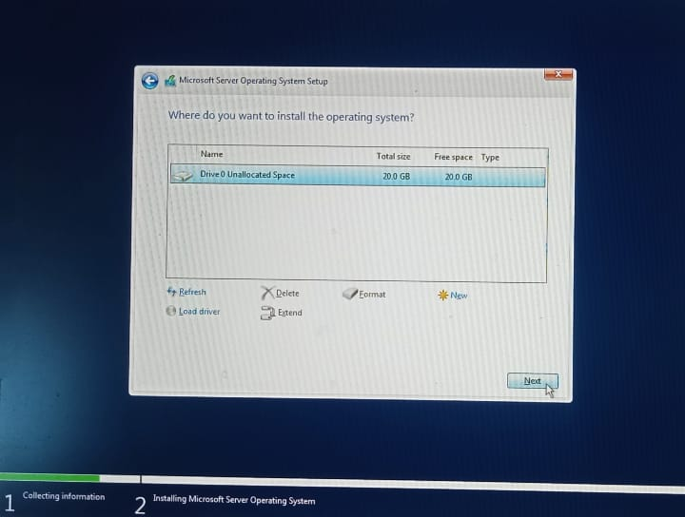

11. Now it will start automatic to installing. Keep wait for installation fully and if any personal or others information it asks then provide it.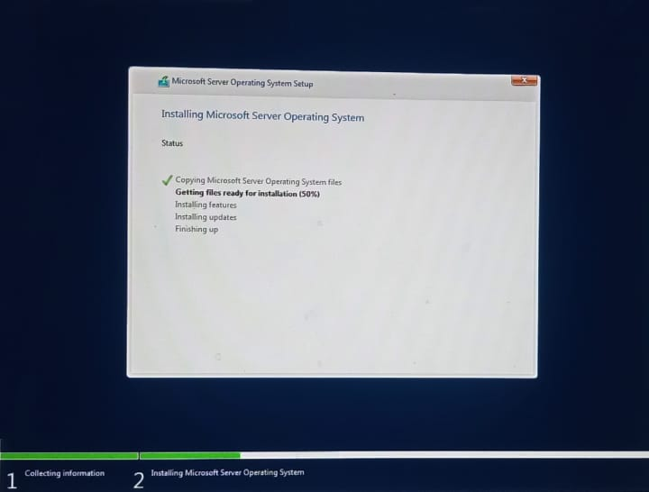12. Give Password for **Customize settings.** Here user name Administrator will show no need to worry it is fixed here. Then **click** on **Finish**.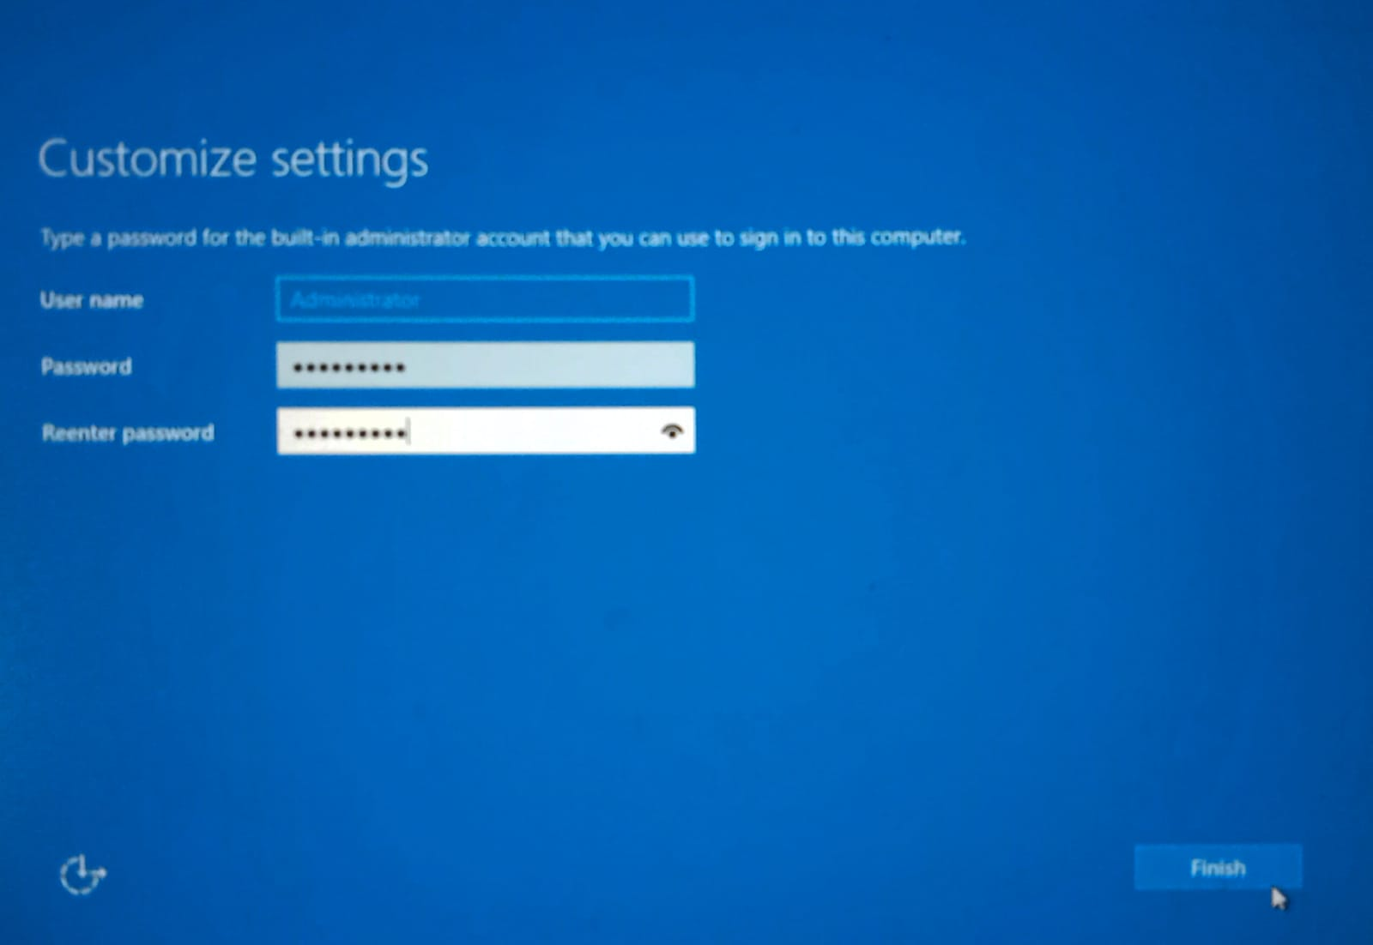13. By **Pressing Ctrl + Alt + Delete** keys at the same time and giving **Password** that we have set in **Customize settings** we will see our **New Windows Server**.



### ****Name of the Experiment****

### Configuration and Management of DHCP (Dynamic Host Configuration Protocol), ADDS (Active Directory Domain Services), and DNS (Domain Name System) in a Networked Environment.

### ****Objectives****

### To configure and manage a DHCP server for dynamic IP address allocation.

1. To implement Active Directory Domain Services (ADDS) for centralized network management.
2. To configure and test the DNS service for hostname-to-IP resolution.
3. To understand the interdependence of DHCP, ADDS, and DNS in a network environment.

**Required Components for DHCP, DNS and ADDS**

**Hardware**

* A computer system or virtual machine capable of running Windows Server.
* Network switch/router for physical setup.
* Network interface cards (NICs).

**Software**

* Windows Server (2019/2022 or equivalent).
* Client operating systems (e.g., Windows 10/11).

**Network Components**

* Static IP addresses (for server configuration).
* Cat5e/6 cables (if using physical machines). After adding some configuration and adding some necessary tools in task bar and finally by opening **Server Manager** we can get our desire server.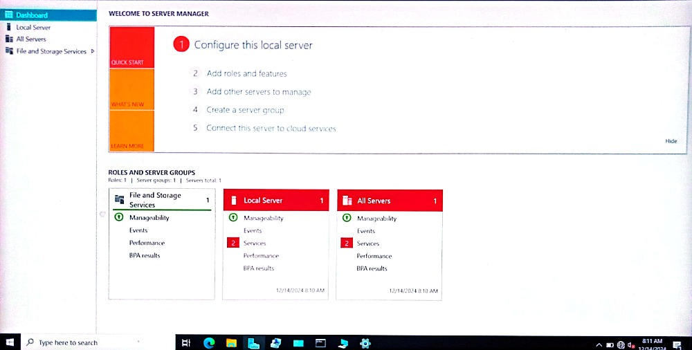

1. After configuring in **Local Server** go to **Manage** for **Add roles and features**.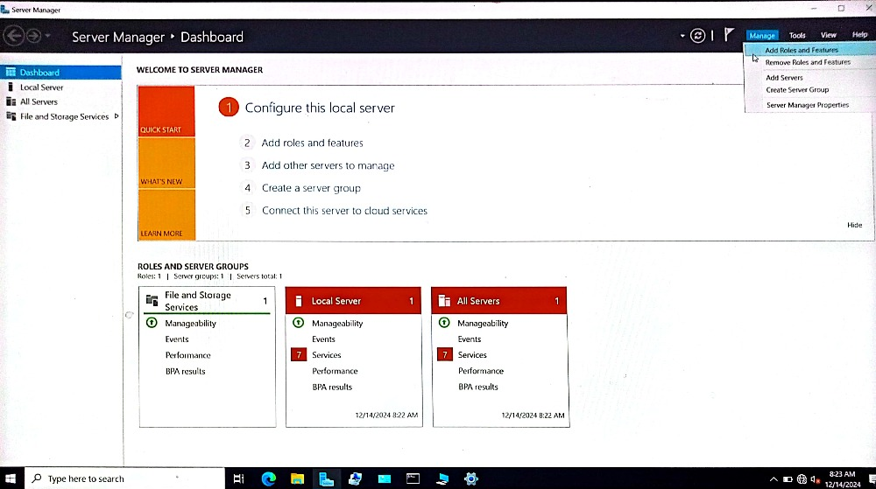16.Now begin to install the three things that are **DNS**, **DHCP** and **ADDS**.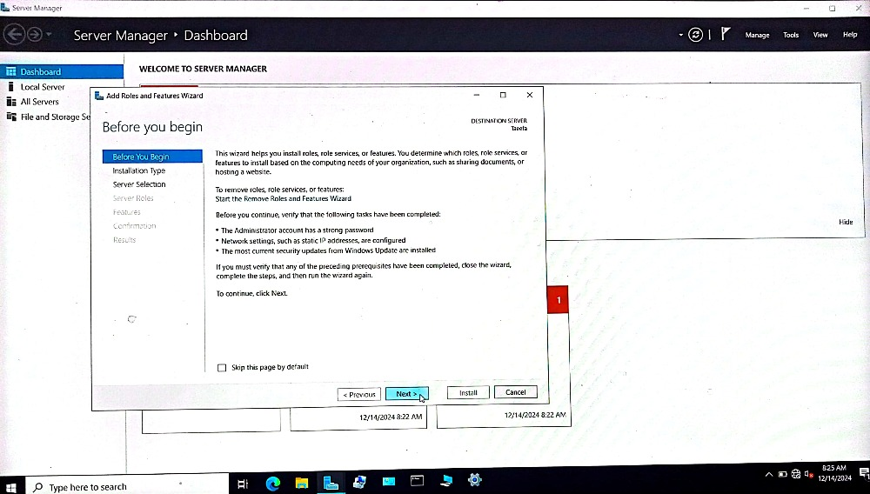

17. Selecting necessary options or press next for all the installation process.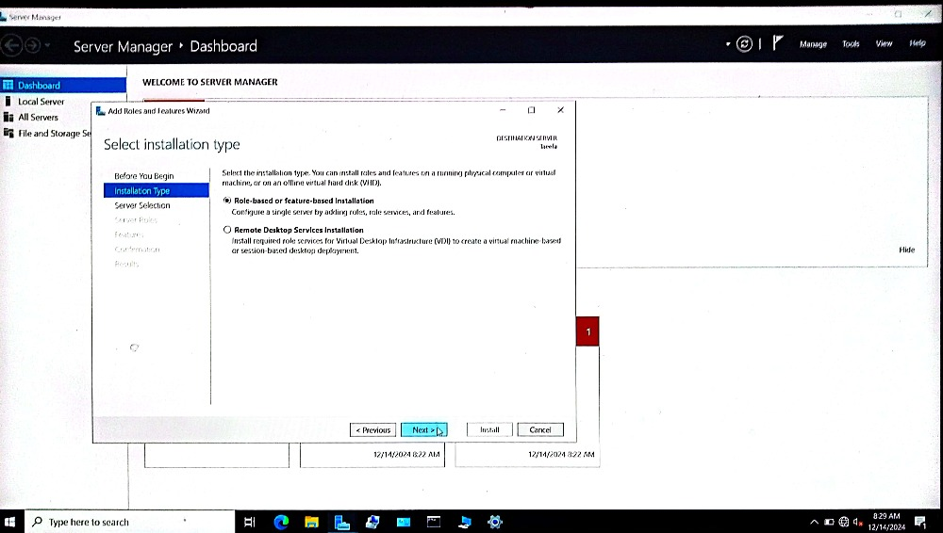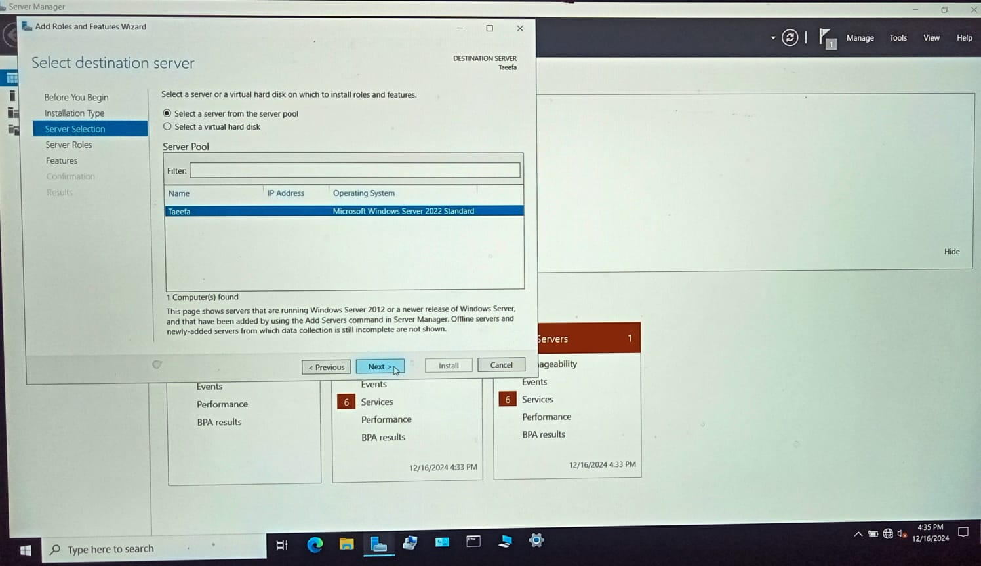

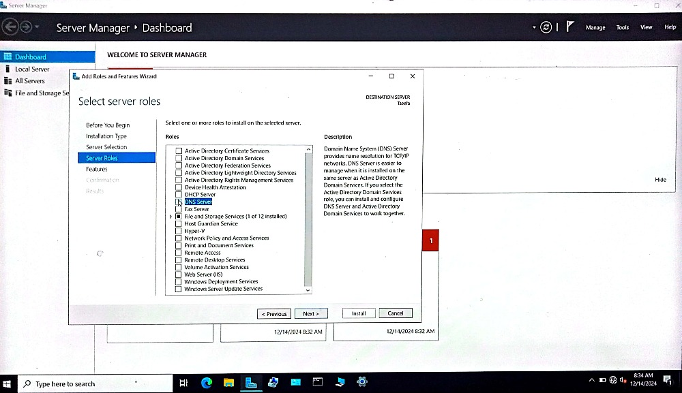

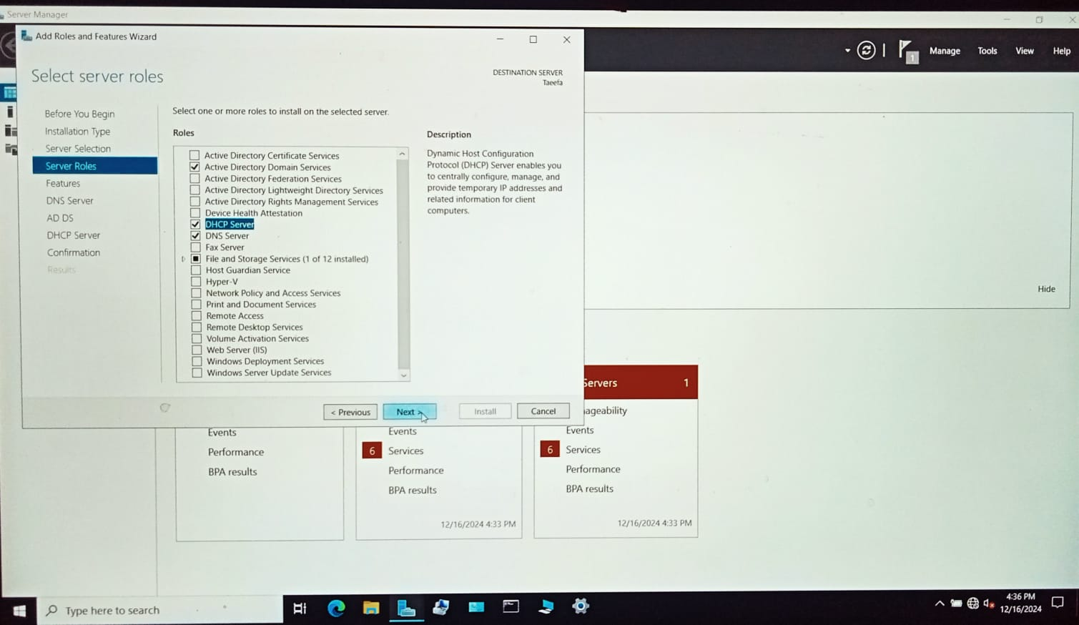

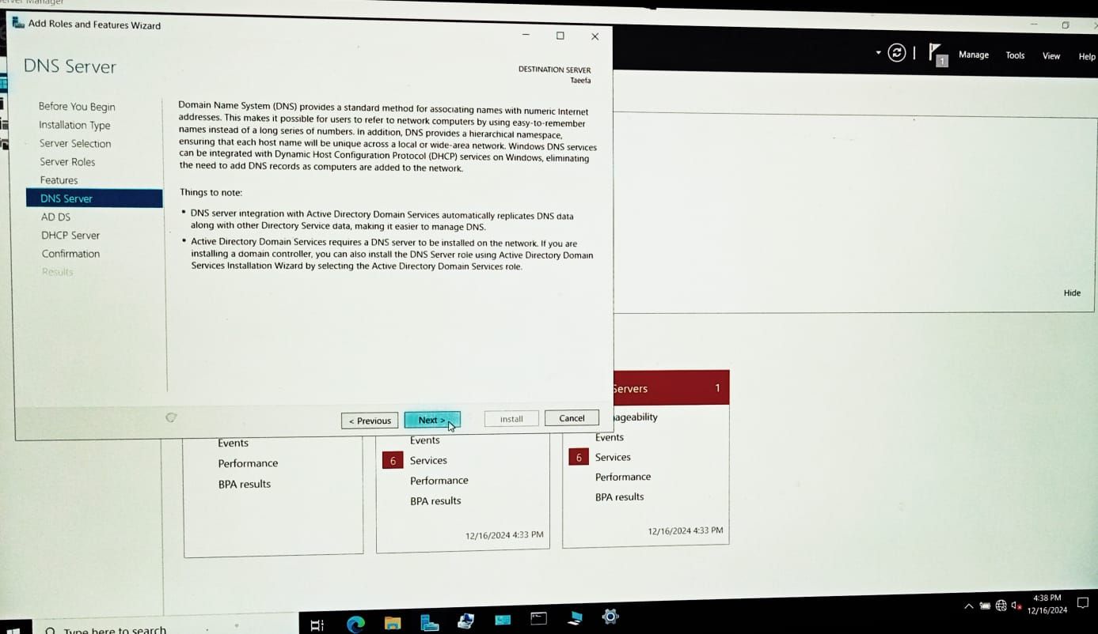

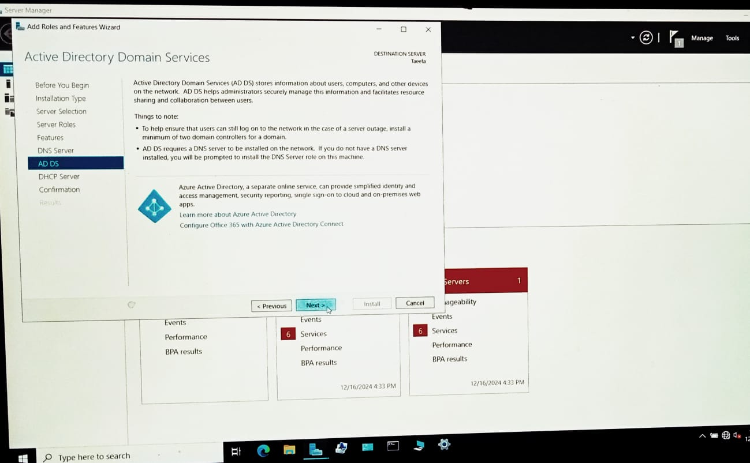

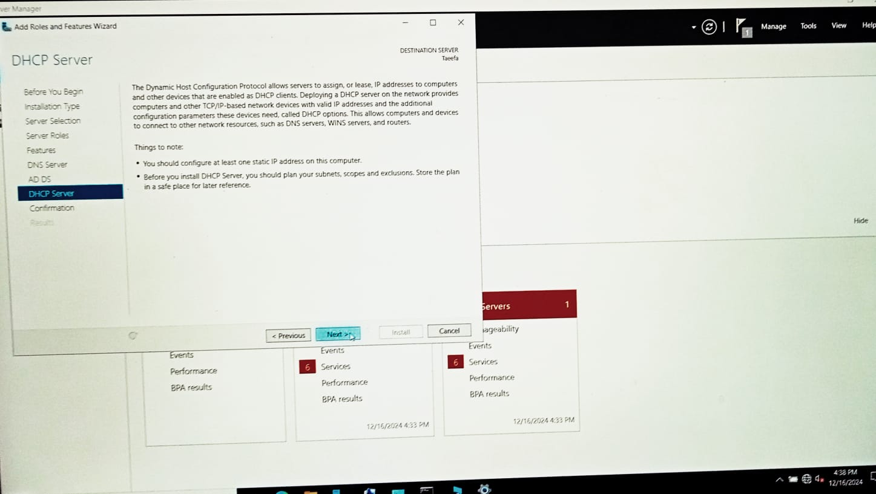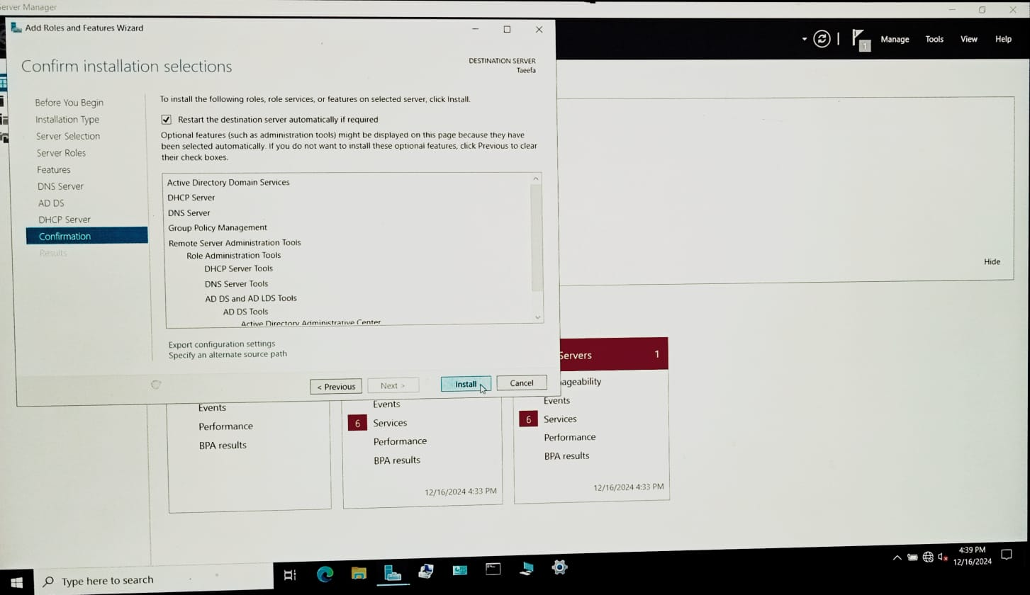

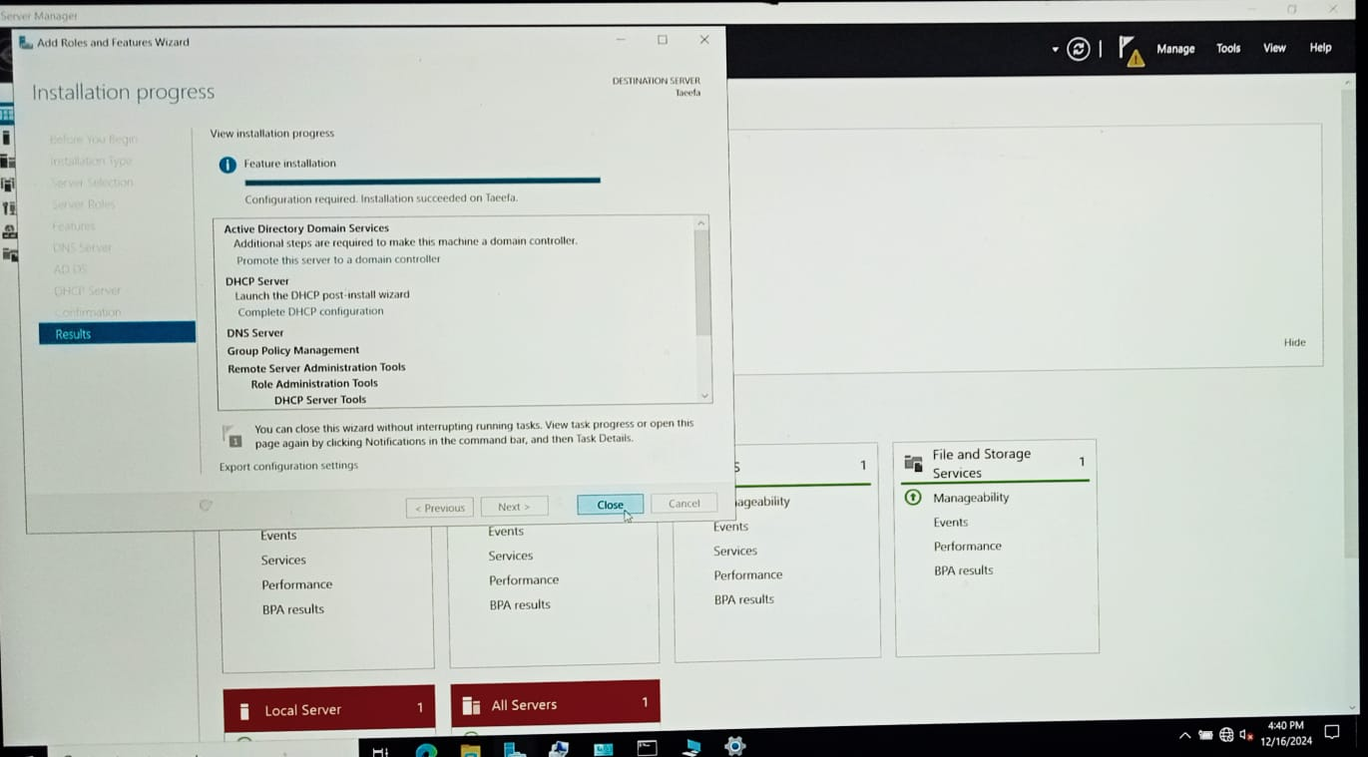

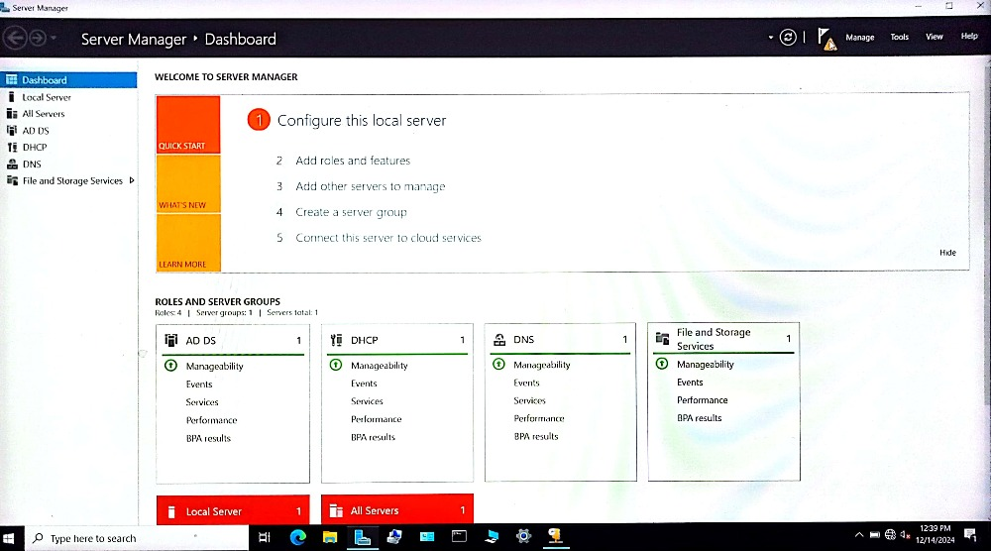

*** Now change in local server for firewall off, Giving IP address for Ethernet and remote desktop enable.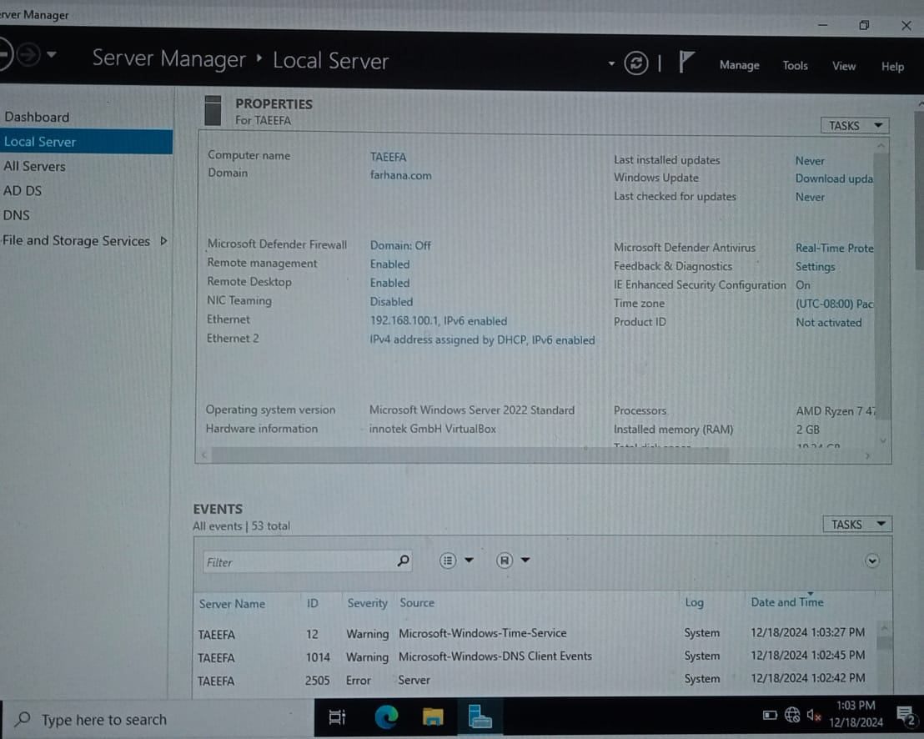

#### ****Experiment: DNS Configuration only in our new server without ADDS****

### ****DNS (Domain Name System)****

* **Objective:** To configure a DNS server.
* **Tools/Software:** Windows Server, DNS.
* **Tasks:**
  1. Install and configure DNS.
  2. Set up forward and reverse lookup zones.
  3. Test name resolution using nslookup in **Command Prompt**.

#### ****Theory****

DNS is responsible for translating human-readable domain names (e.g., www.lab.com) into IP addresses. It plays a critical role in network communication and is integrated with both DHCP and ADDS to provide seamless domain resolution and authentication.

#### ****Procedure****

1. As we already have installed DNS now **Select DNS** from **tools** and from **DNS server select IPv4** and generate **new zone.**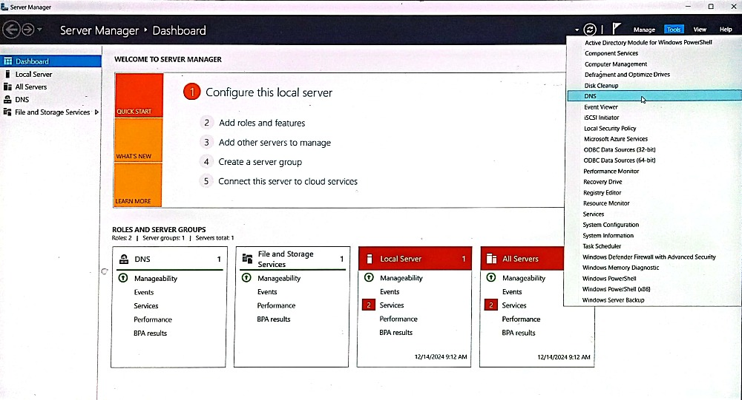

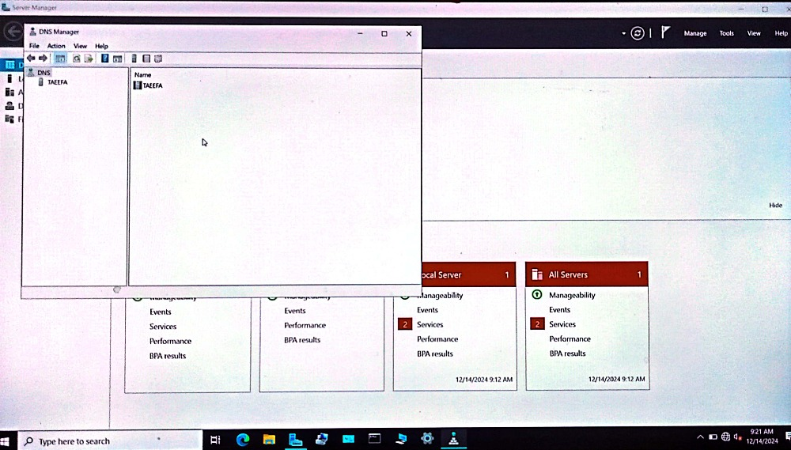

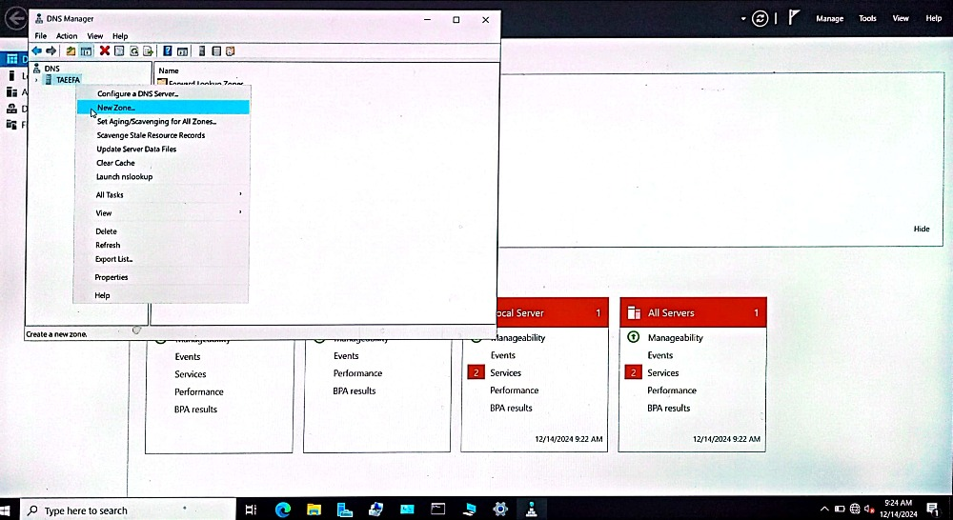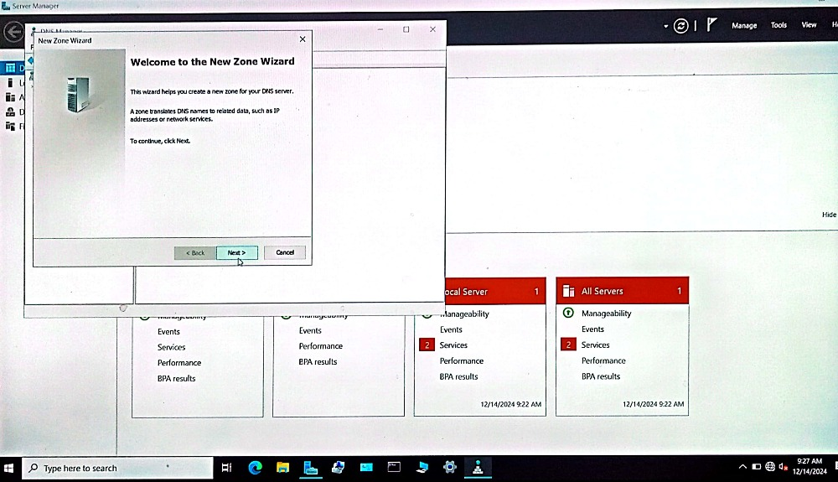

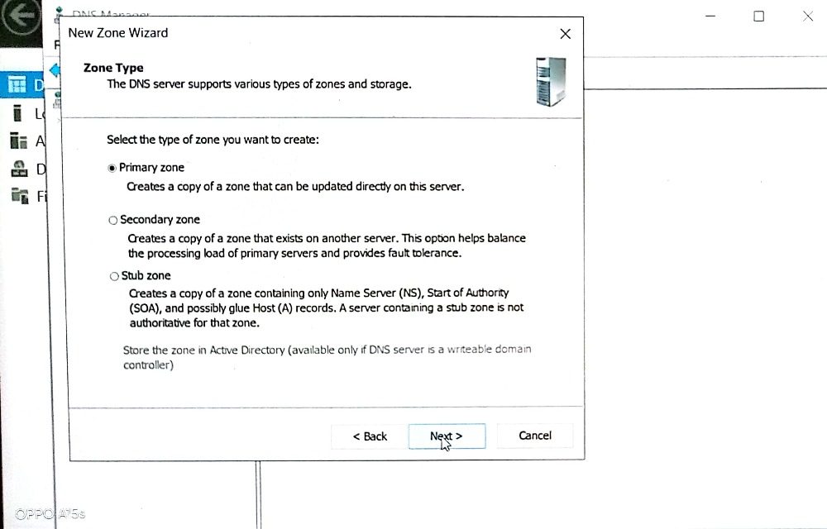

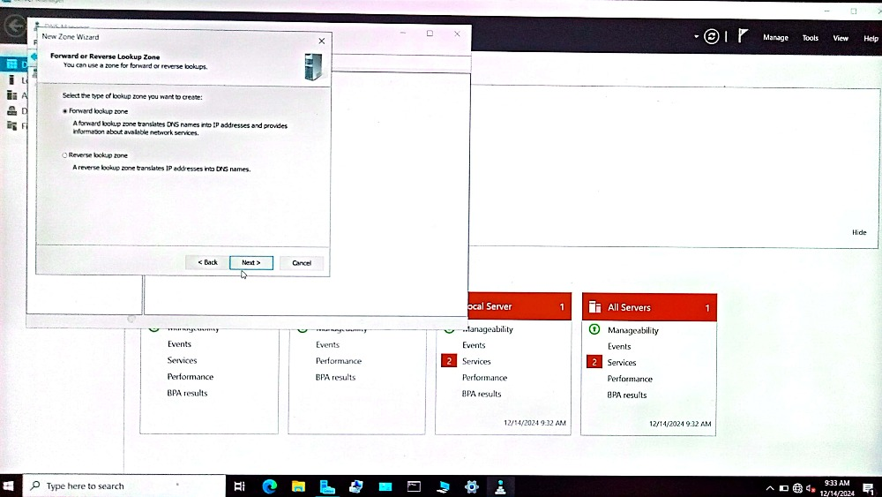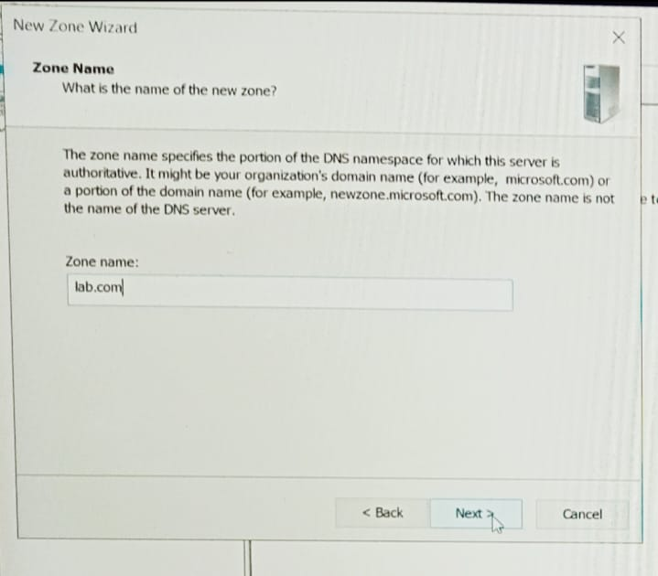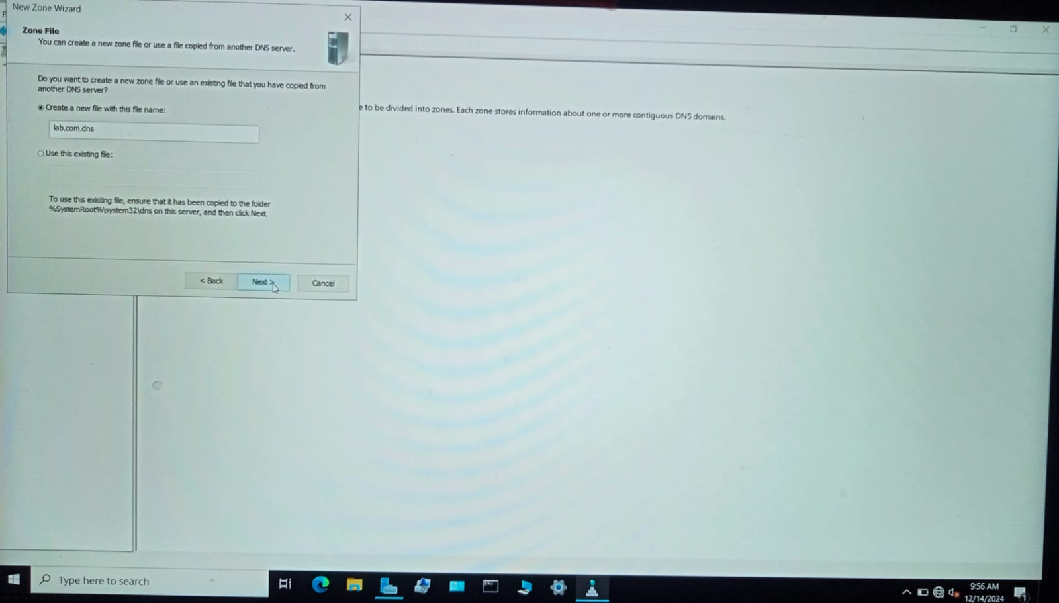

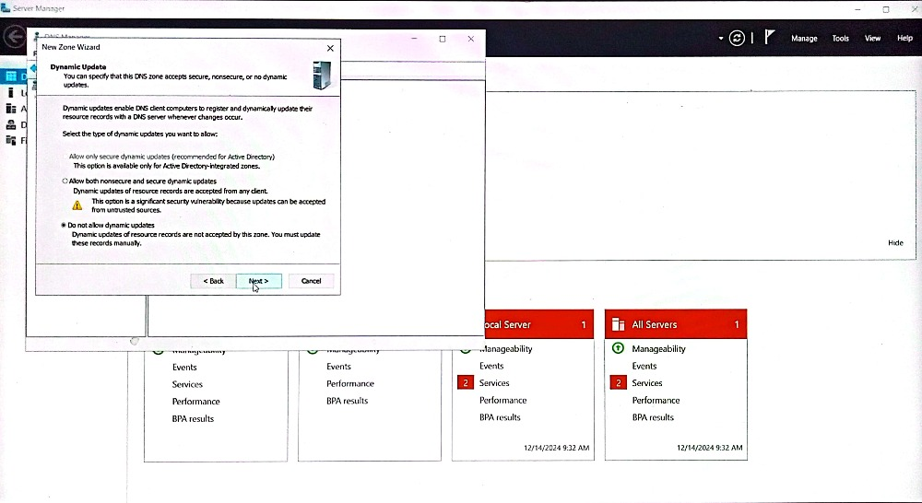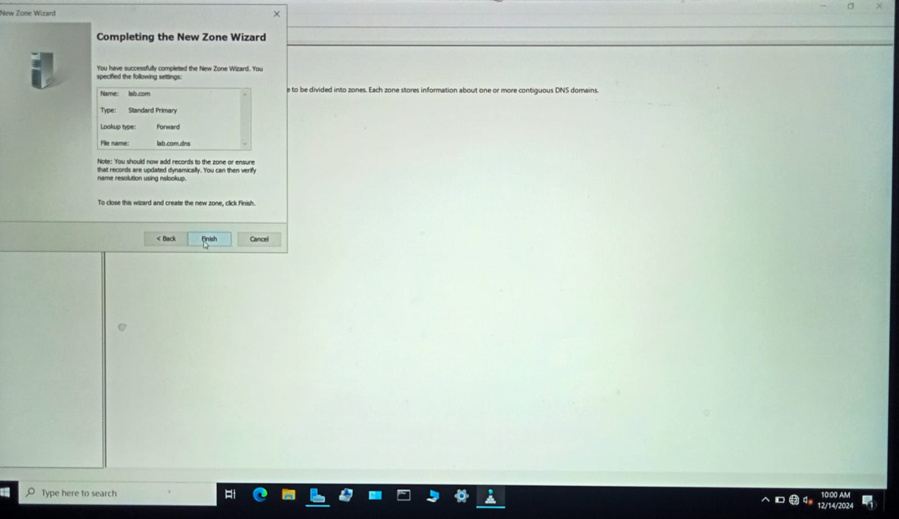**Now make new zone for domain name to IP address and vice versa.**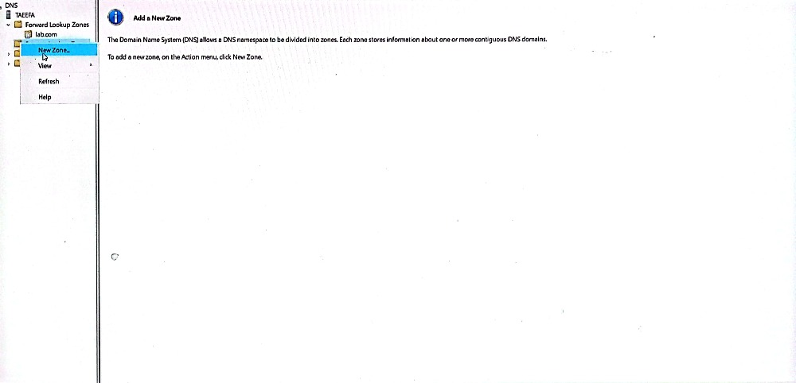

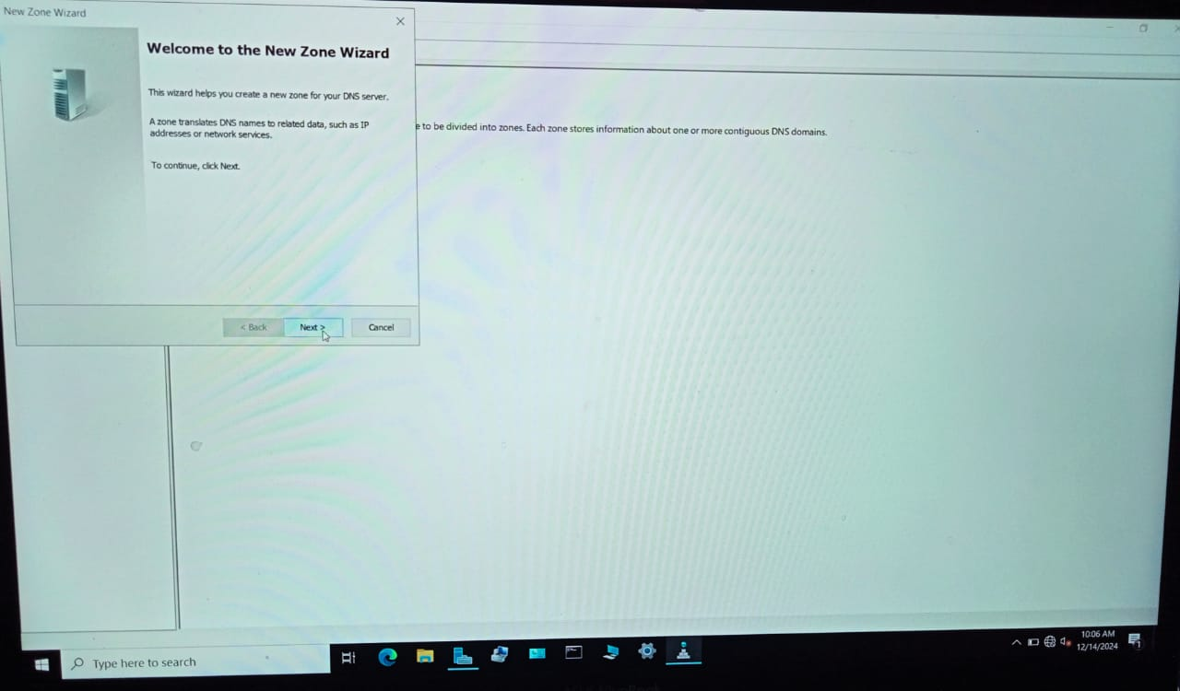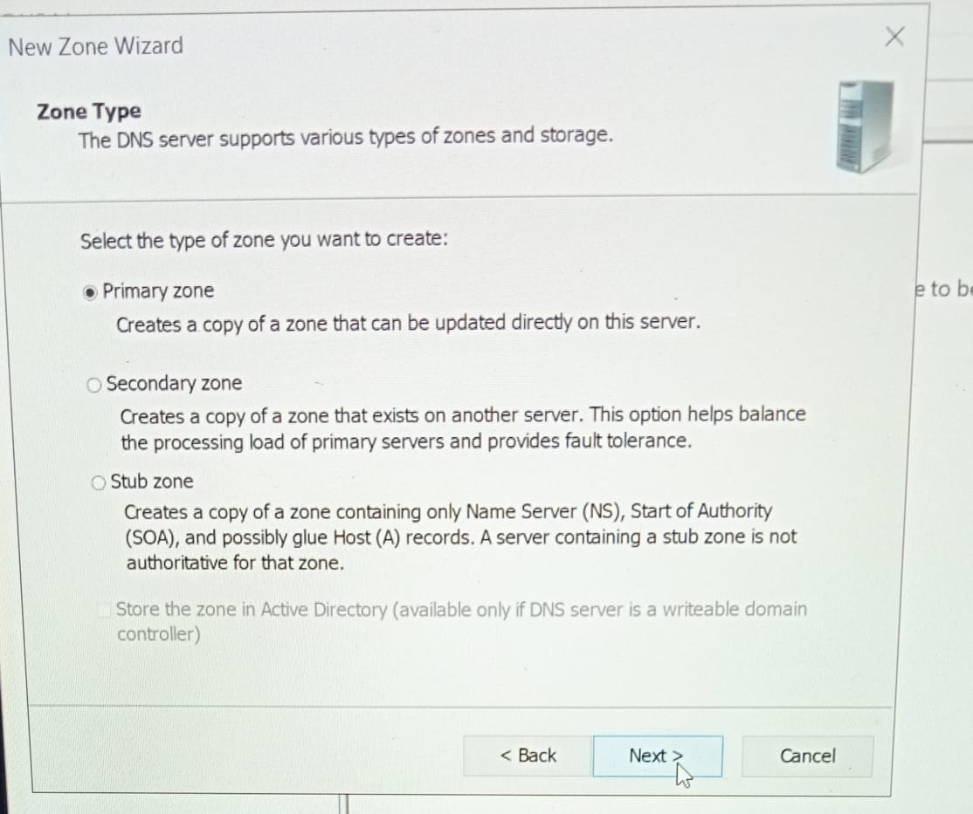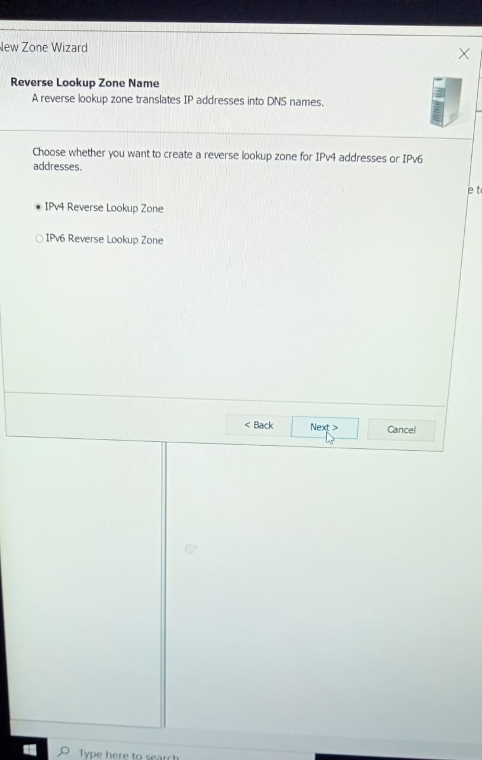

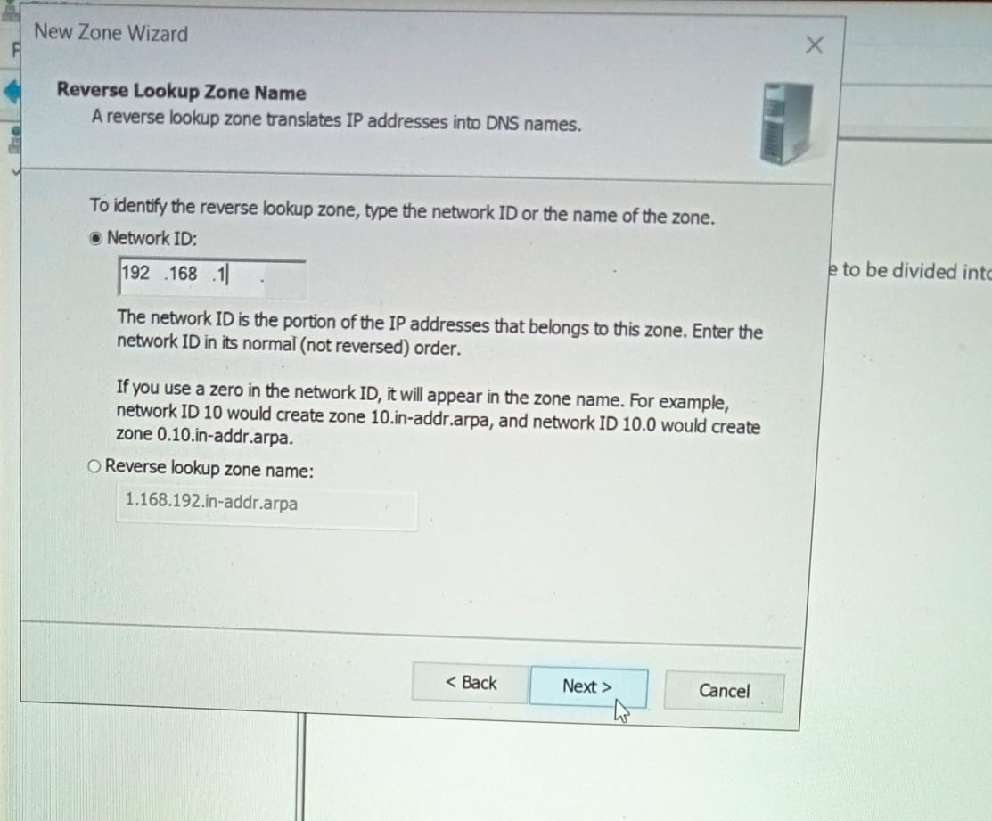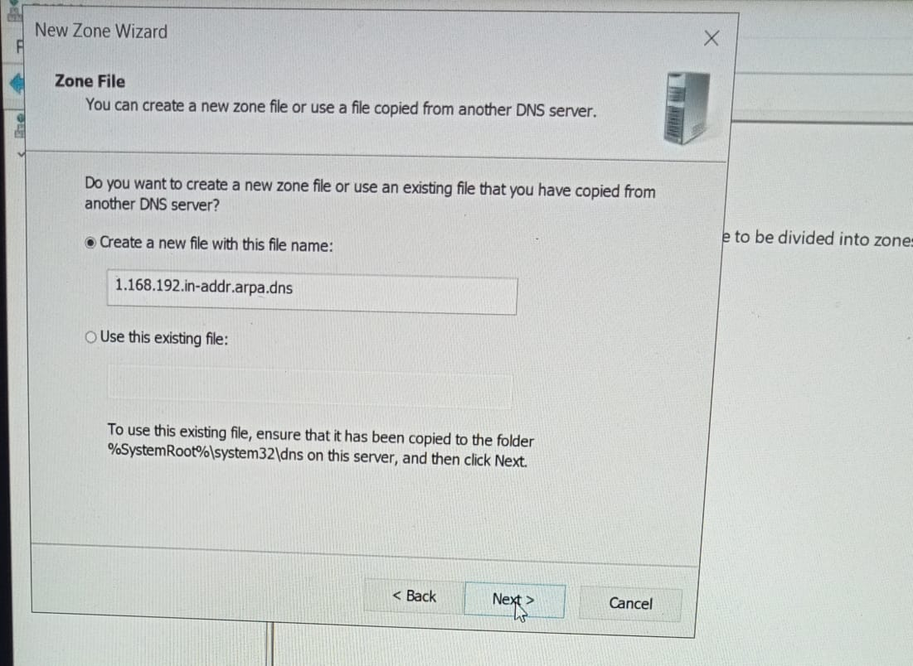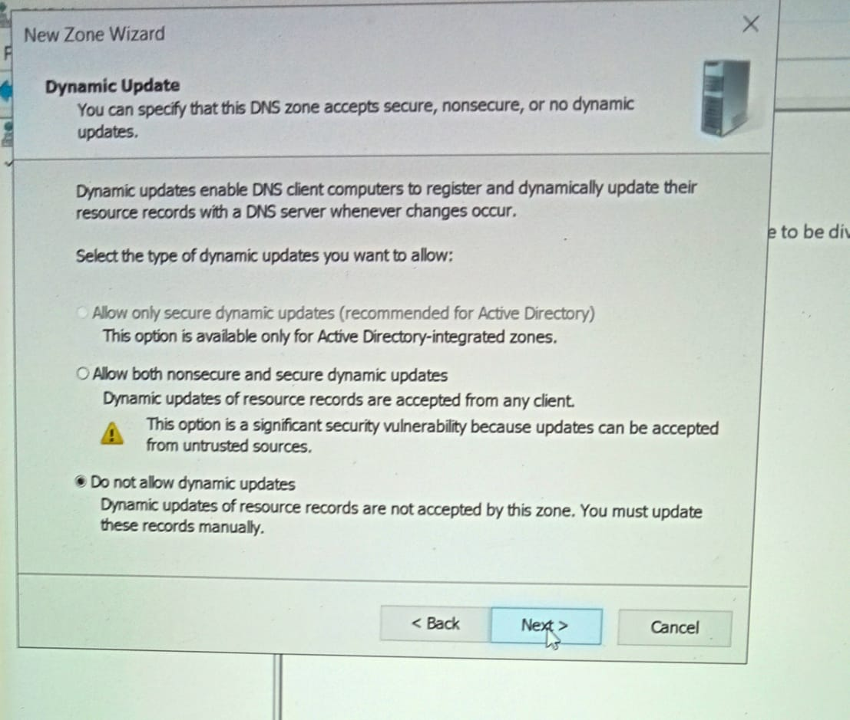

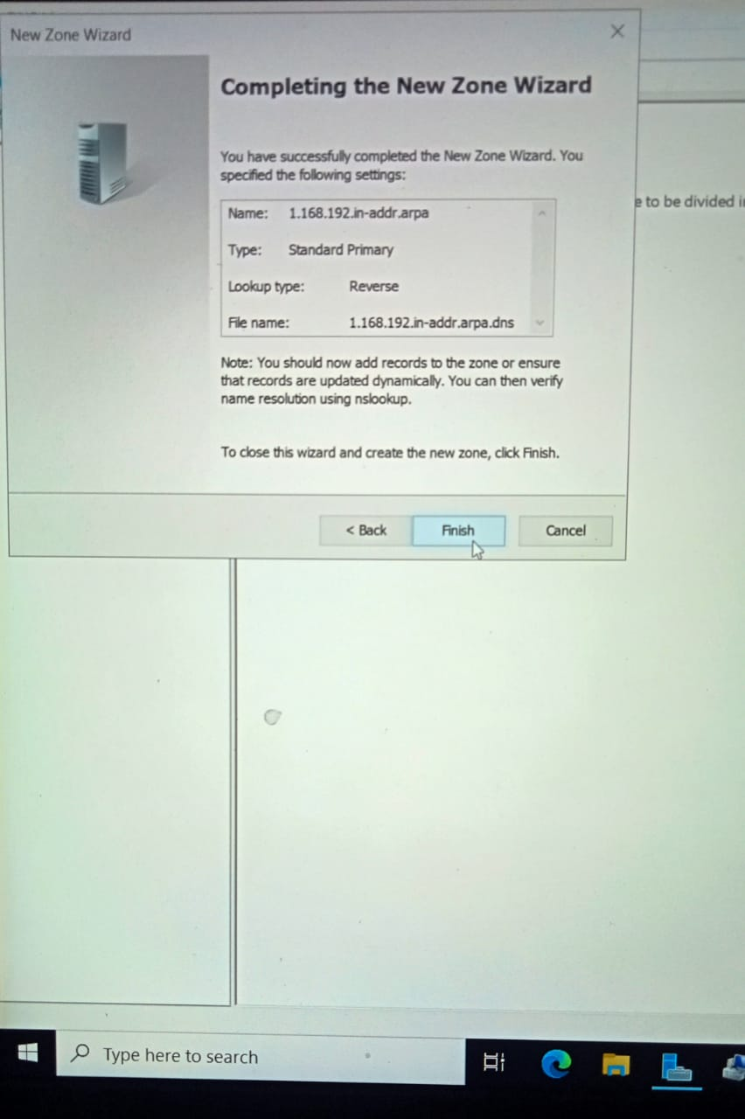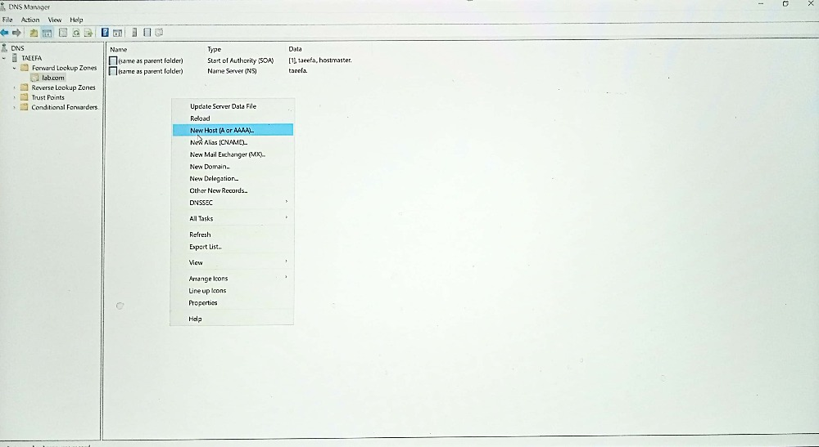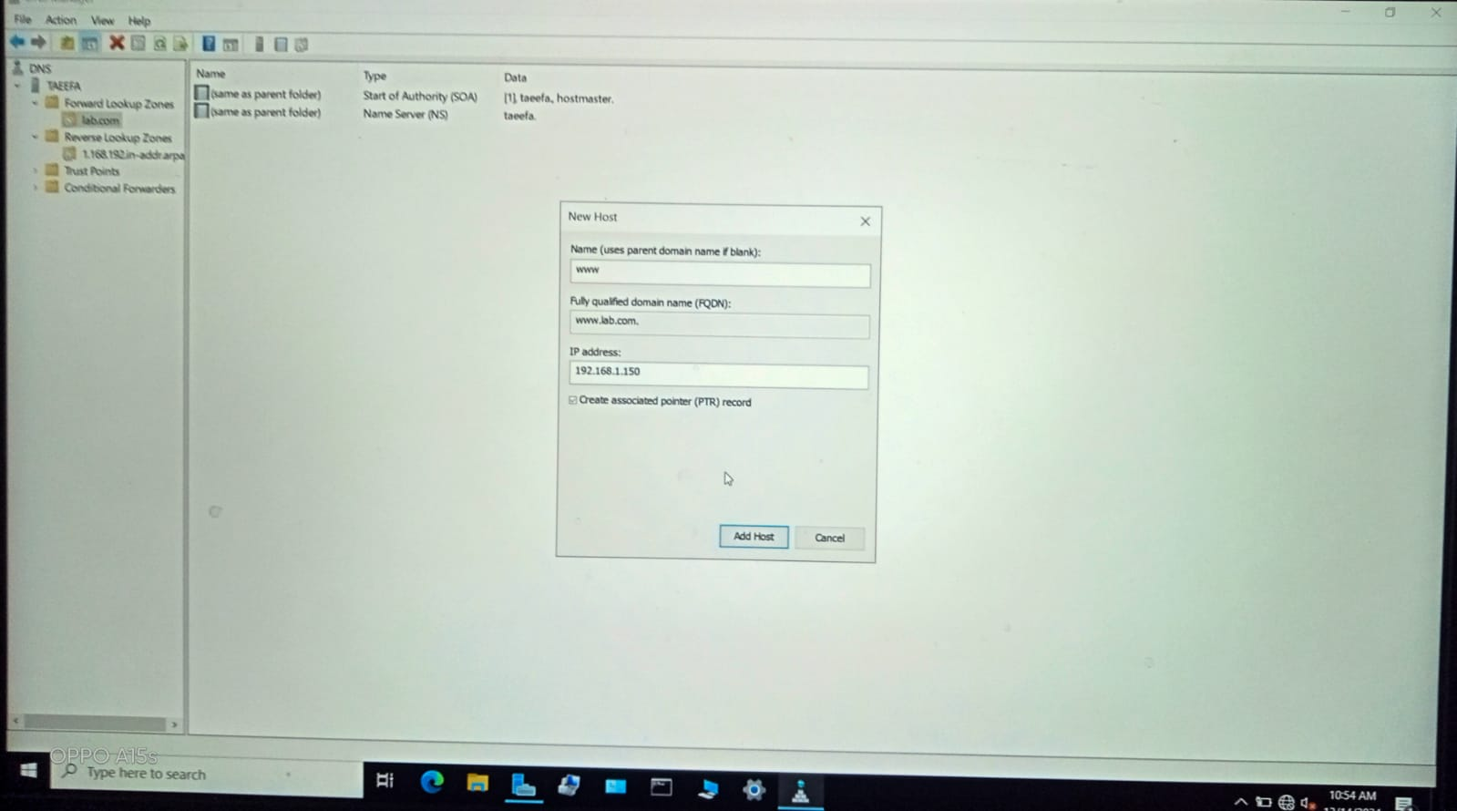

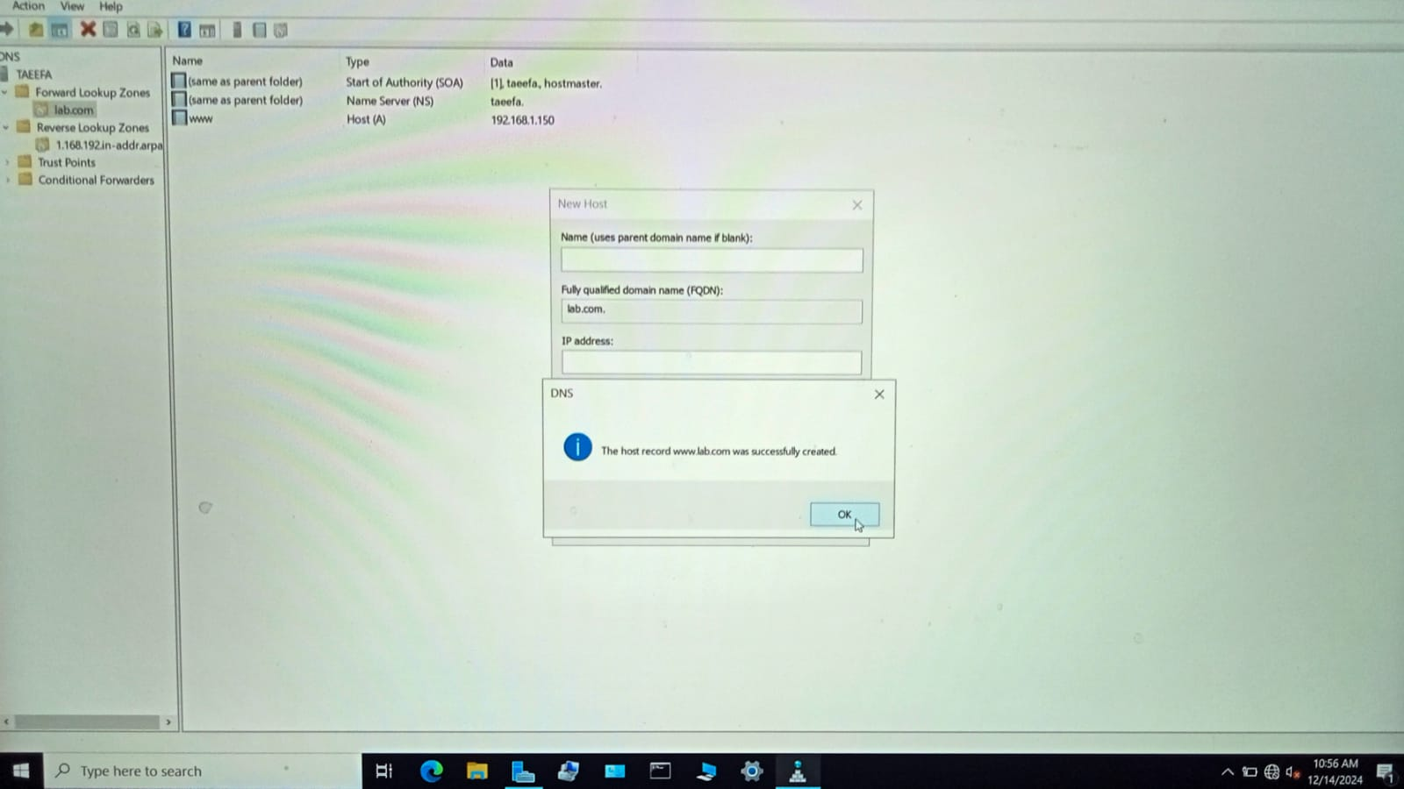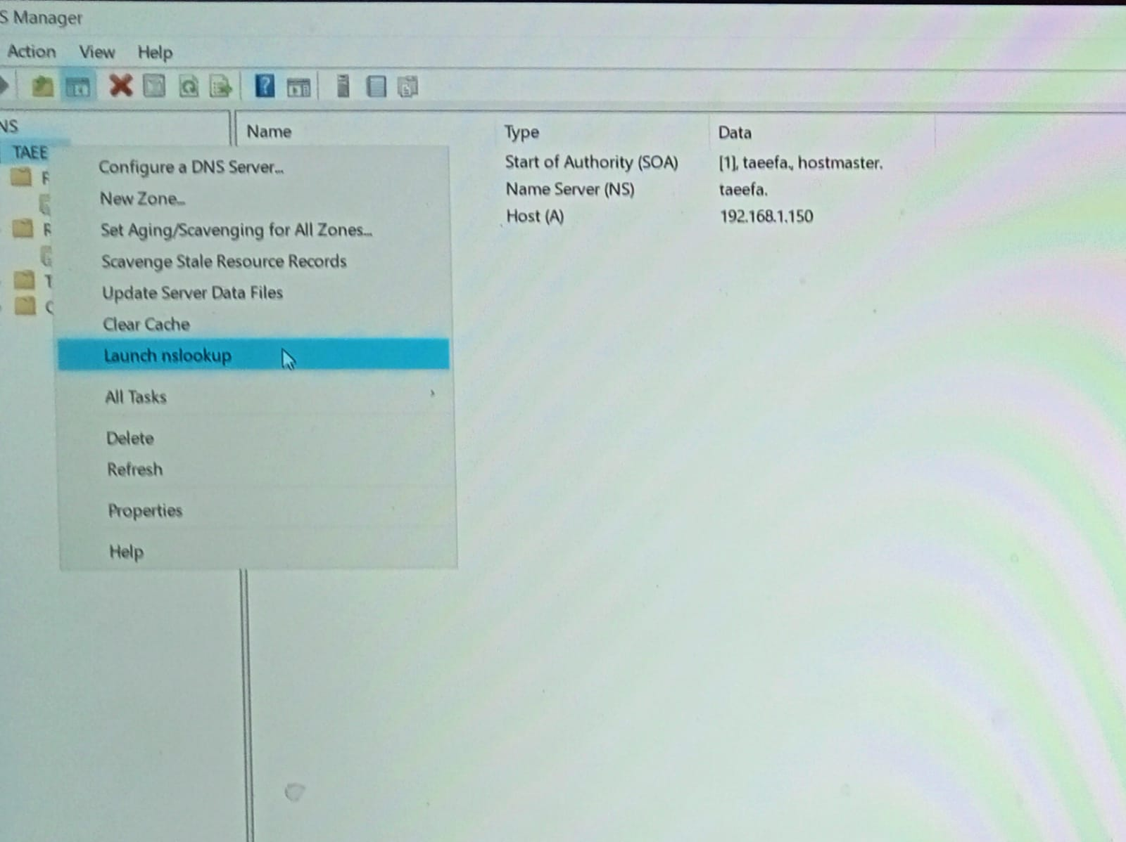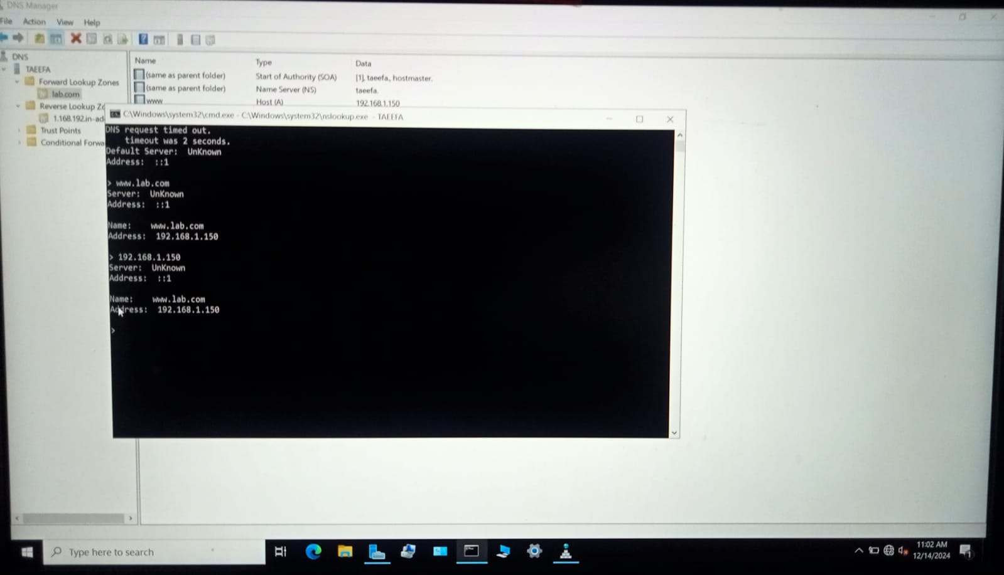

We can check **DNS** properly works or not both from **Command Prompt** and **Launch Lookup**.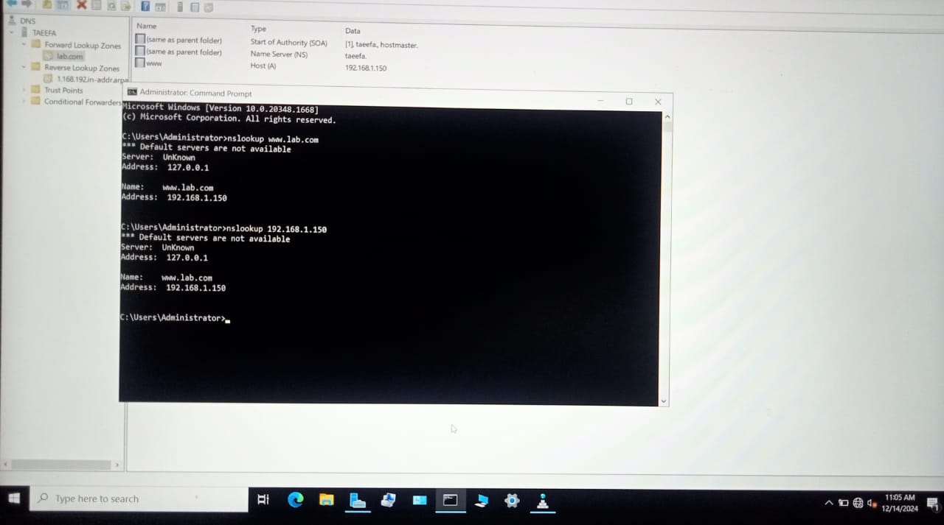

#### ****Observations****

* **Hostnames** resolved correctly to **IP addresses**, and vice versa, using **nslookup** and **ping** commands in **Command Prompt**.

#### ****………………………………………………………………………………………….****

#### ****Experiment: DHCP Server Configuration****

### ****DHCP (Dynamic Host Configuration Protocol)****

* **Objective:** To configure a DHCP server for automatic IP address assignment to client machines.
* **Tools/Software:** Windows Server/Linux Server, DHCP server.
* **Tasks:**
  1. Install and configure a DHCP server.
  2. Set up scopes and lease durations.

#### ****Theory****

DHCP is a protocol used to dynamically assign IP addresses to devices on a network. It eliminates the need for manual configuration of IP addresses, simplifying network management. A DHCP server handles lease requests, renewals, and releases.

#### ****Procedure****

1. Configure DHCP and generate a new DHCP scope:
   * Define the IP address range.
   * Set the subnet mask, default gateway, and DNS server settings.
   * Activate the scope.
2. Test DHCP by connecting a client device and verifying dynamic IP assignment.

**Steps: in following pictures**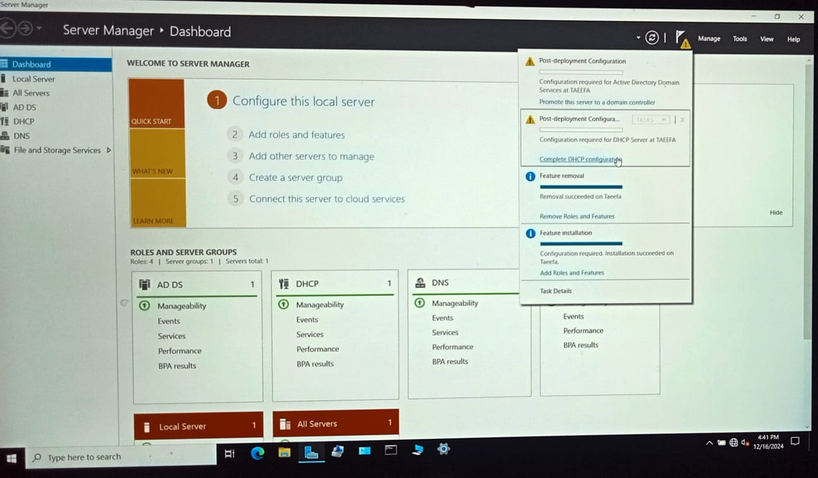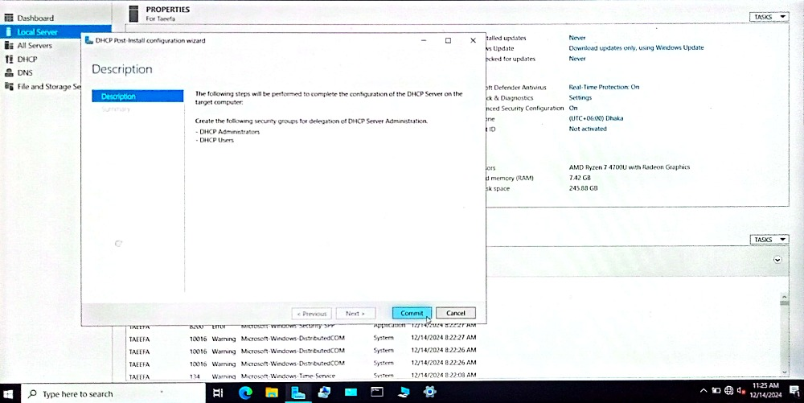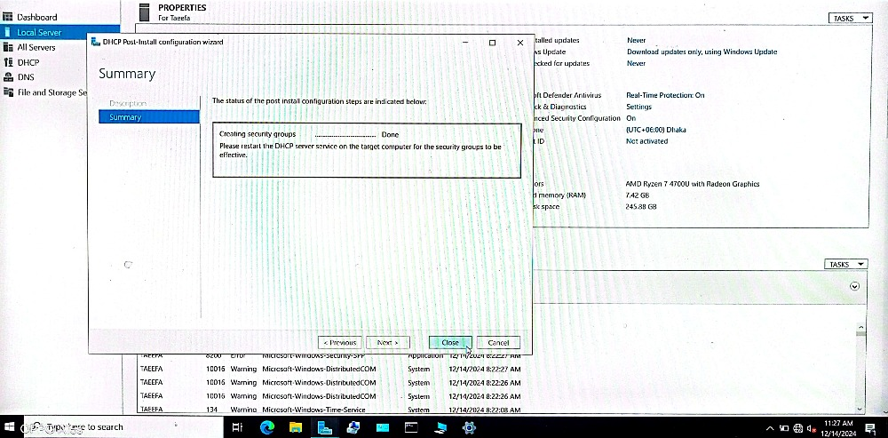

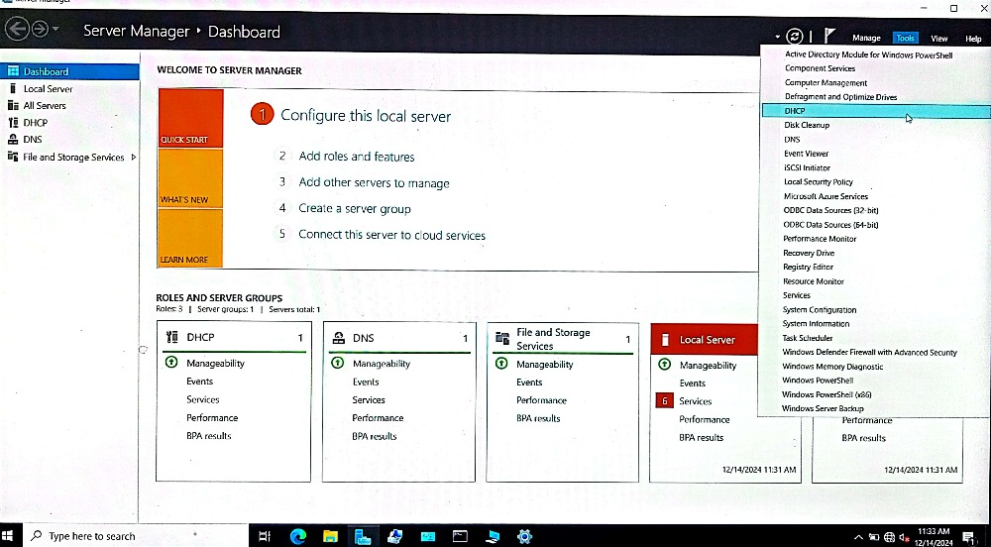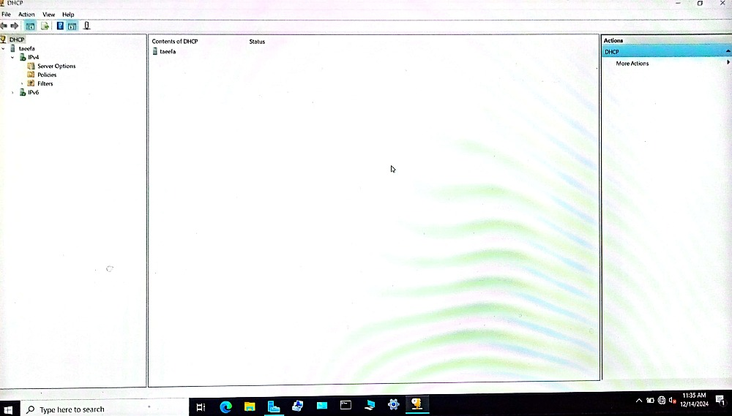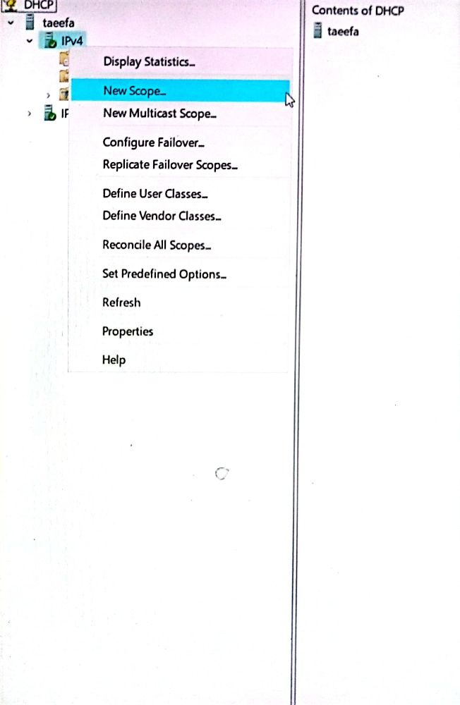

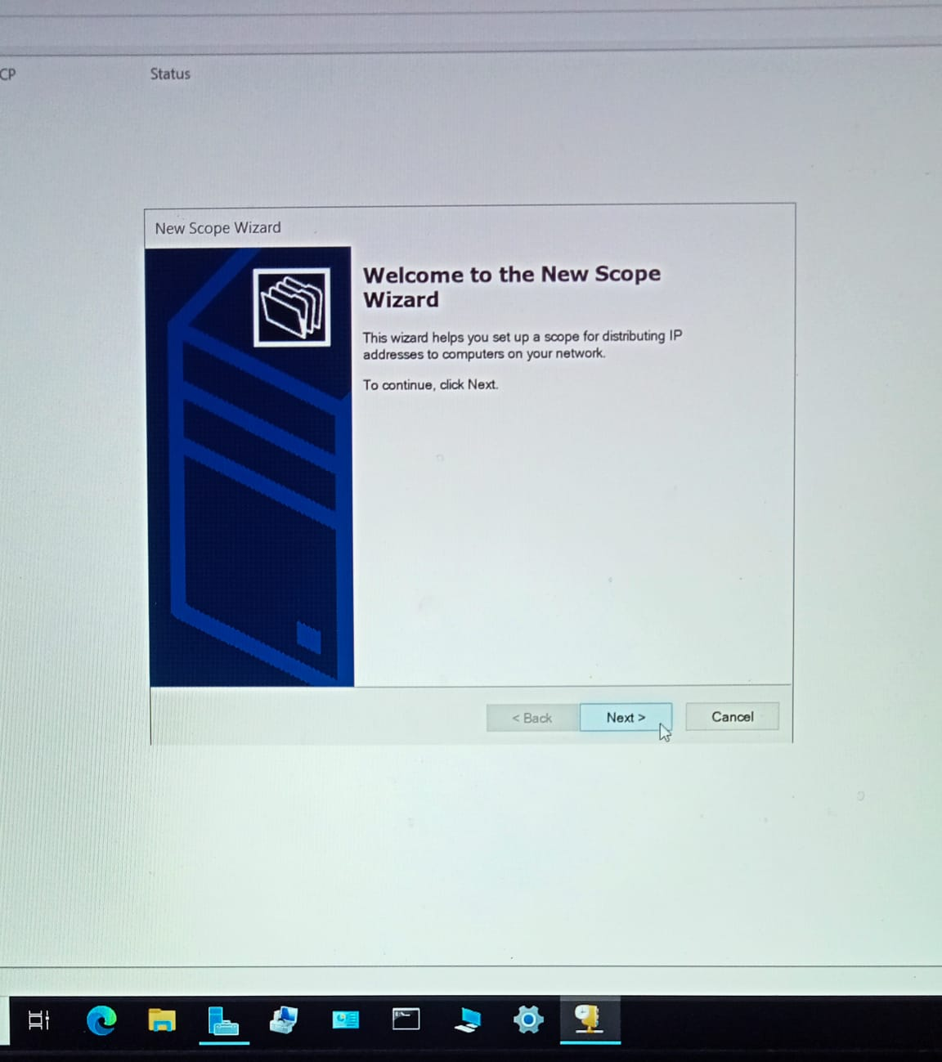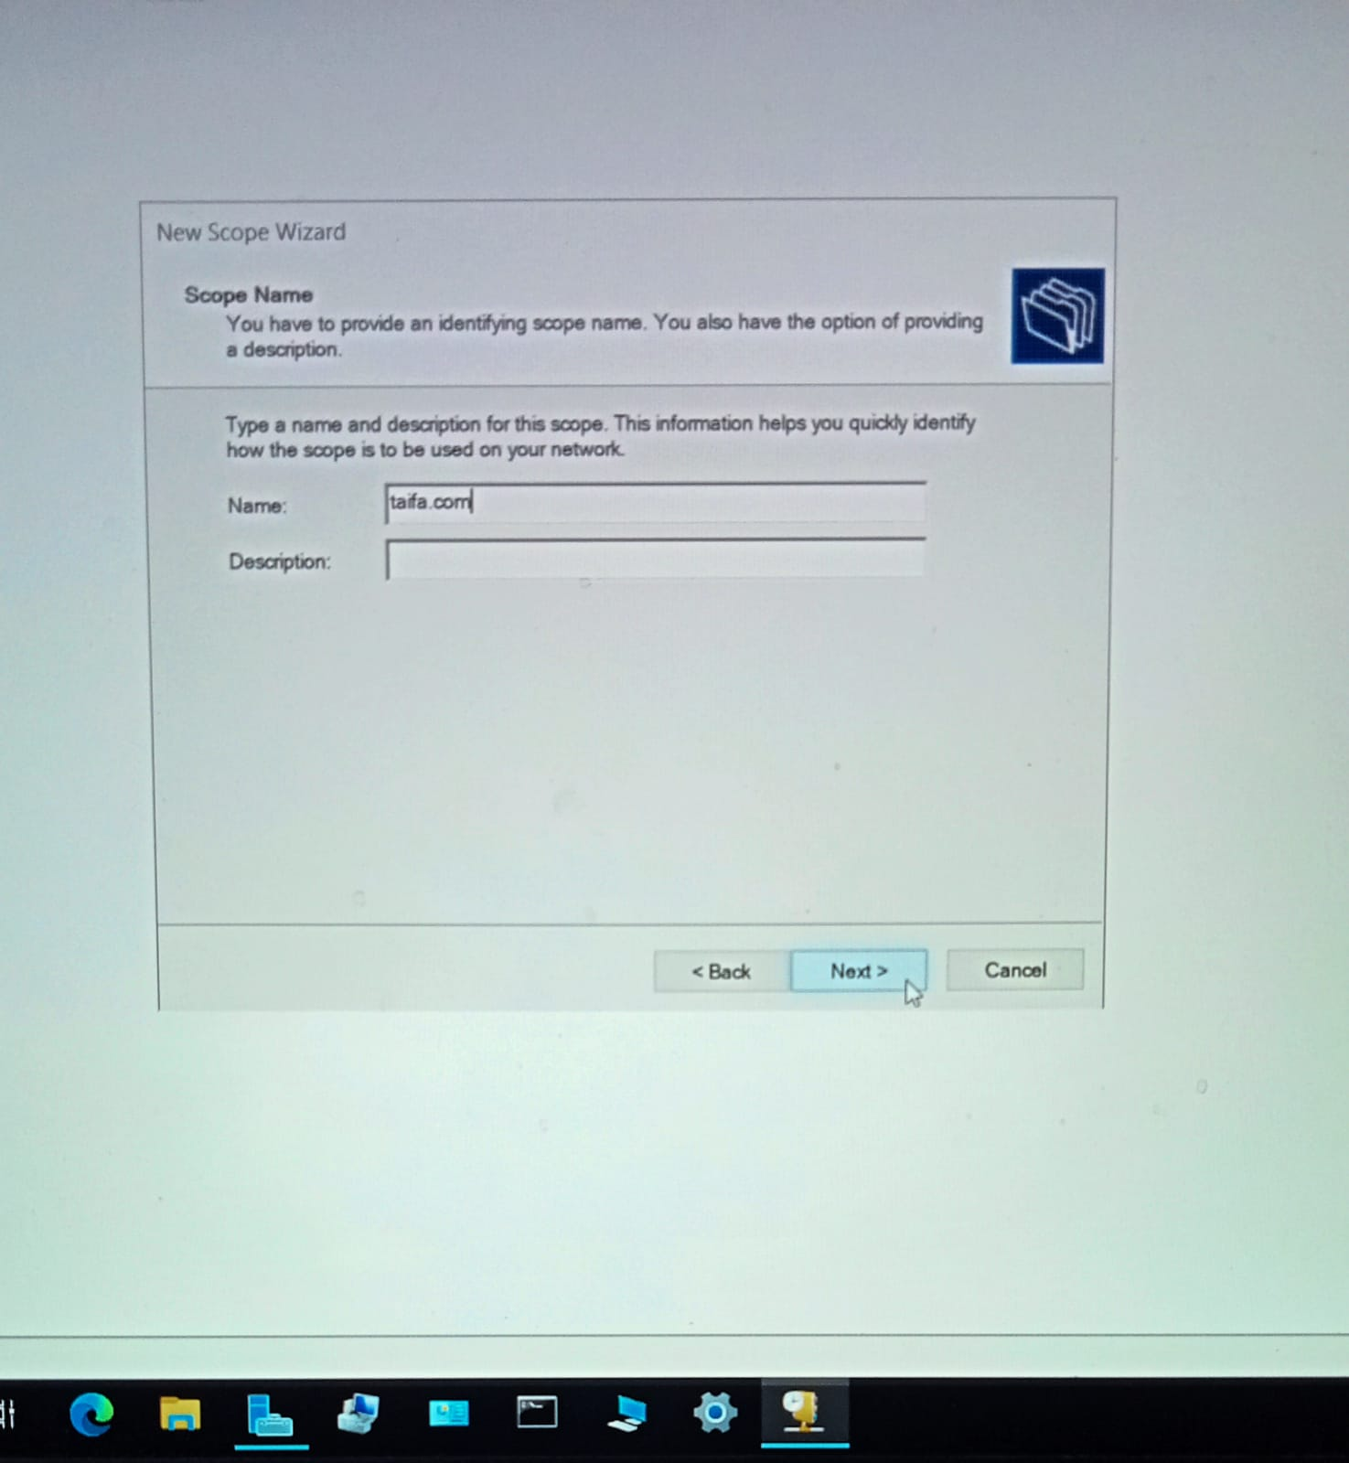

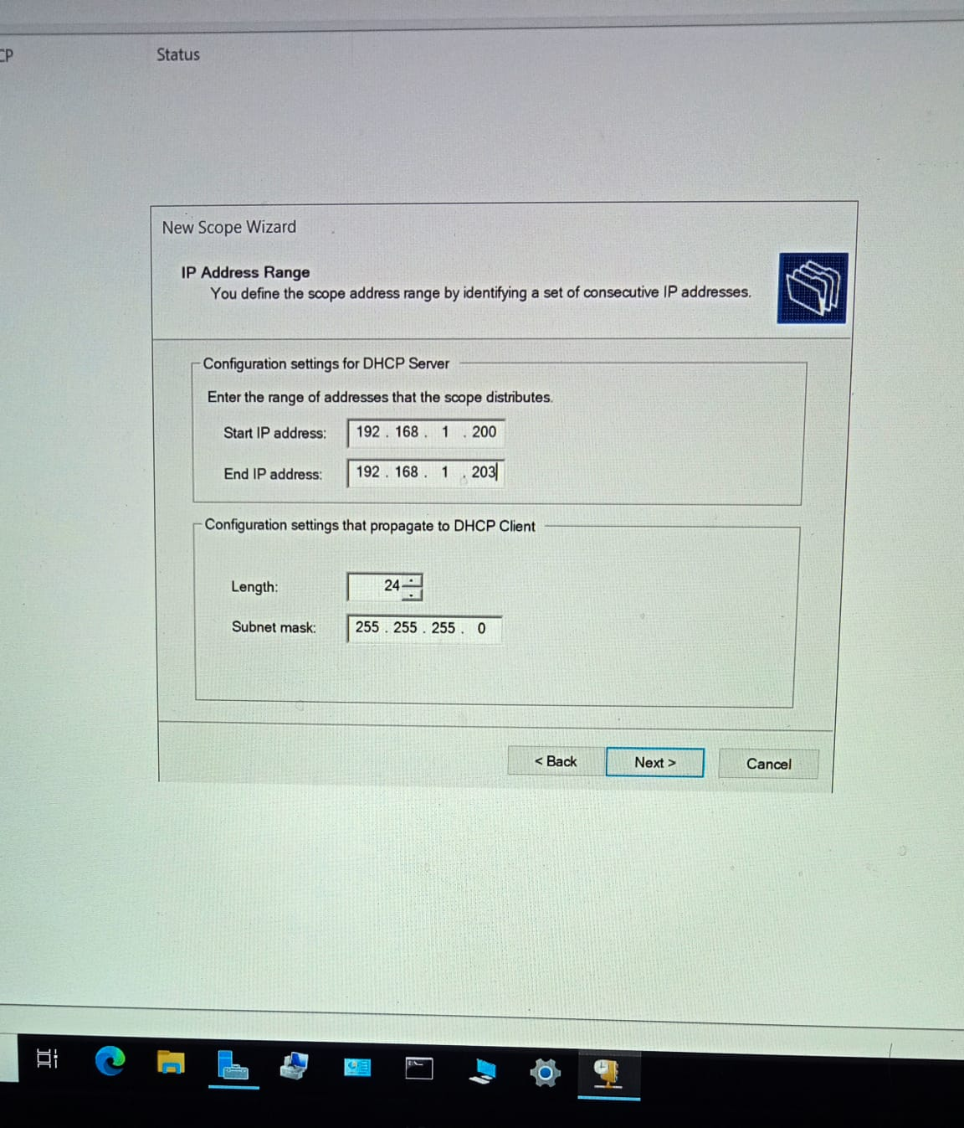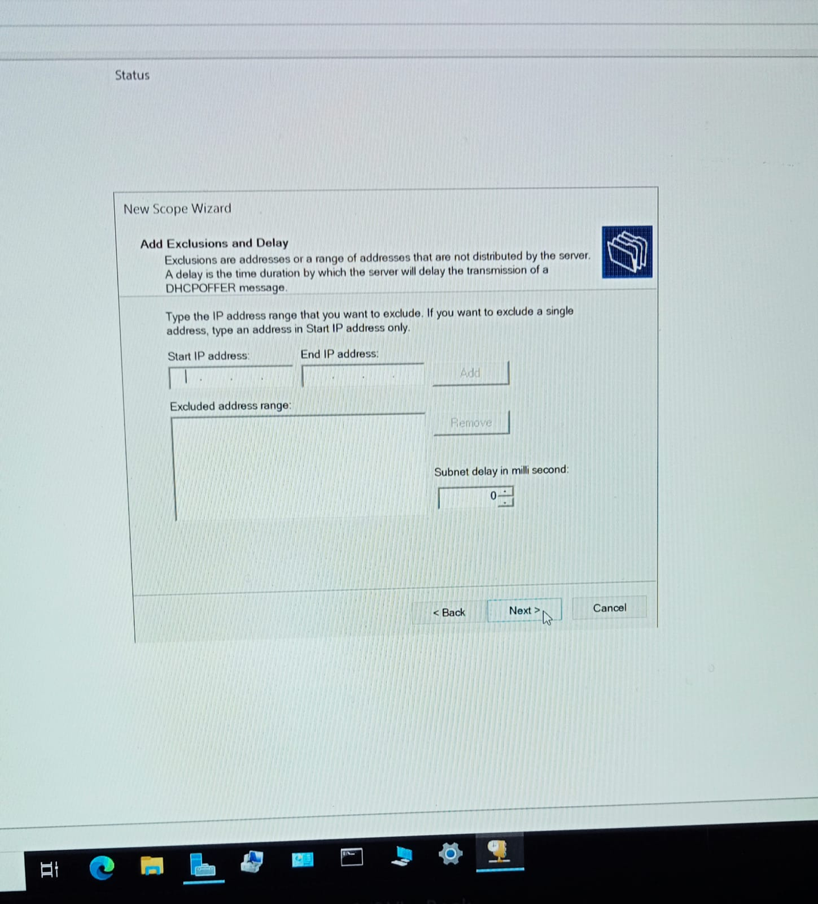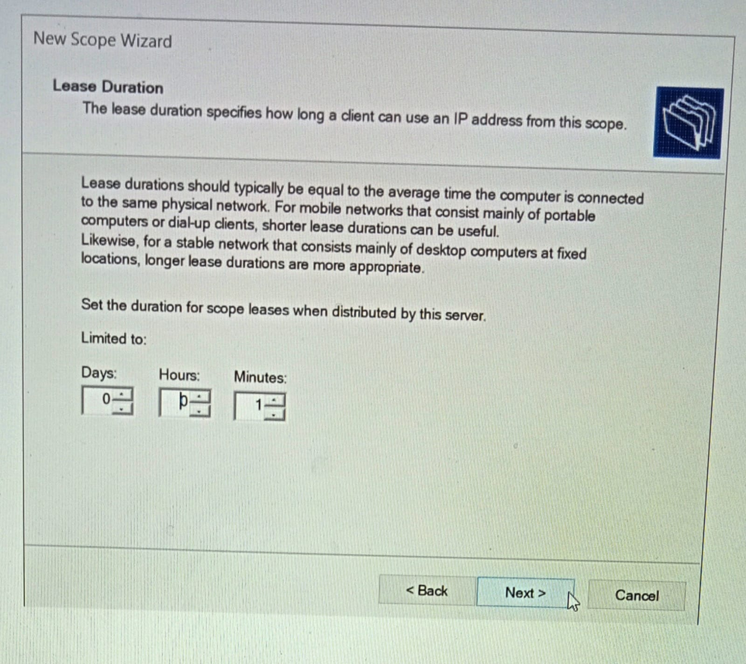

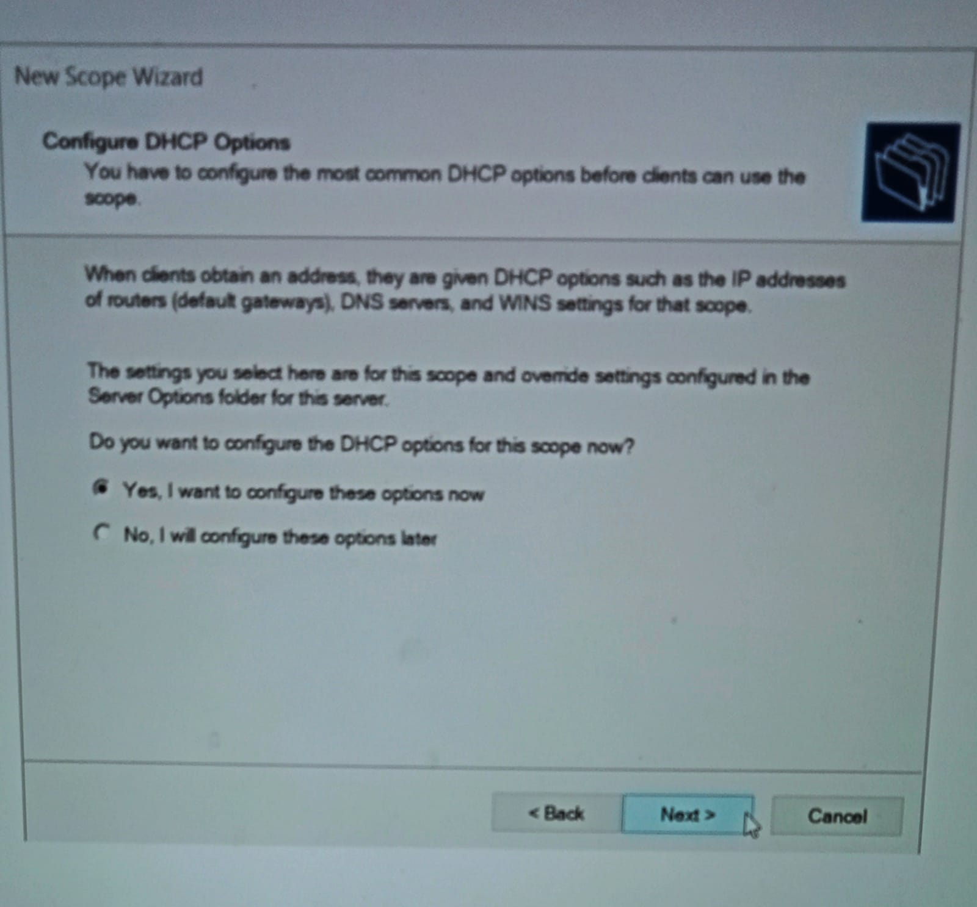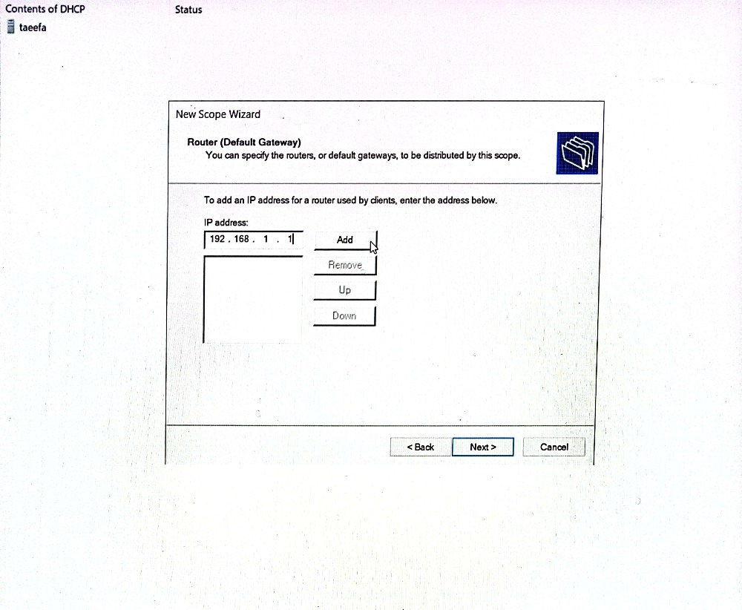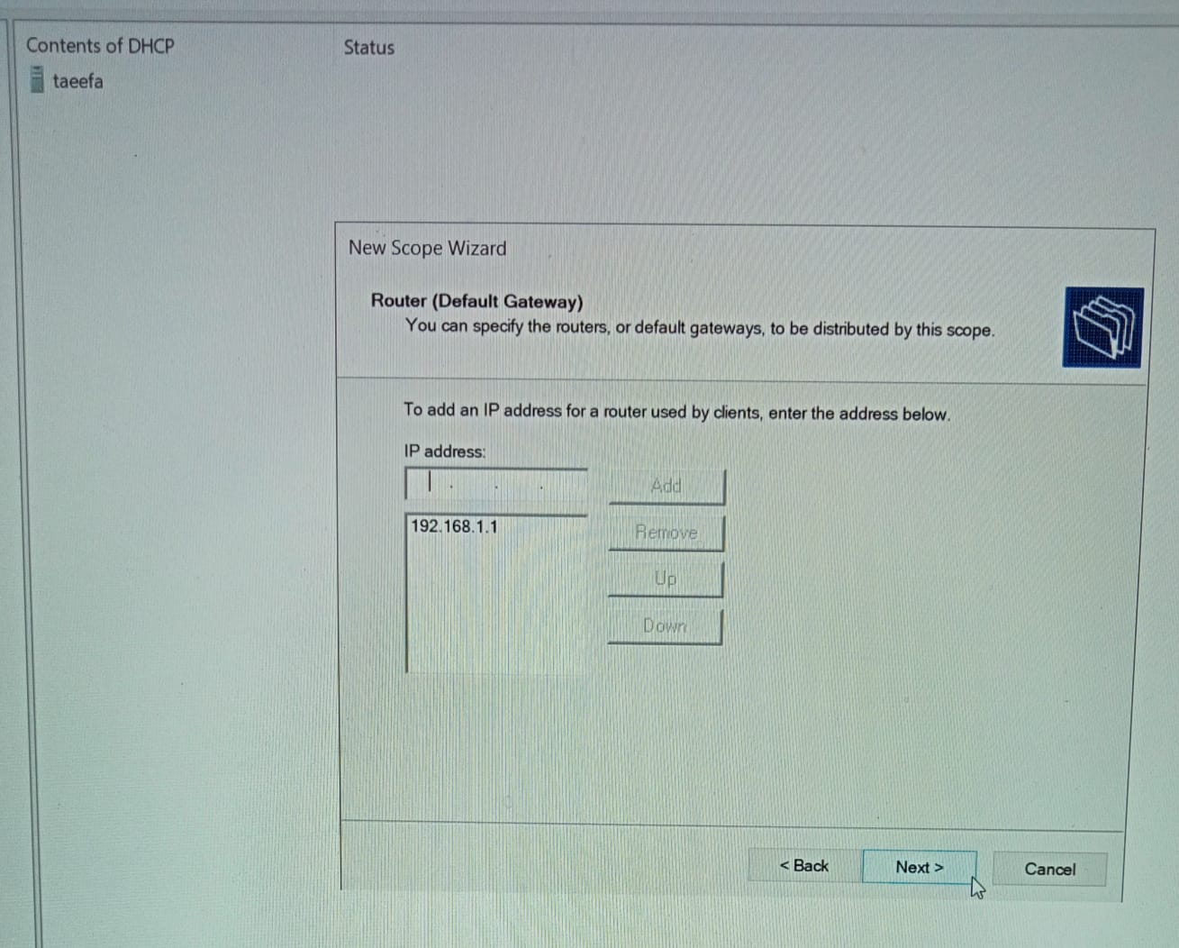

### 

### 

#### ****Observations****

The client device successfully obtained an IP address from the DHCP server. Lease details were visible in the DHCP management console.

**……………………………………………………………………………………**

#### ****Experiment: Active Directory Domain Services (AD DS) Setup****

**ADDS (Active Directory Domain Services)**

**Theory**

ADDS is a directory service by Microsoft that enables centralized domain management. It provides authentication, user and group management, and policy enforcement across a network.

**Objective:** To install and configure AD DS for centralized management of users and resources.

**Tools/Software:** Windows Server.

**Tasks:**

* 1. Install AD DS and configure a domain.
  2. Add users, groups, and computers to the domain.
  3. Join client machines to the domain.

**Procedure**

1. Install the ADDS role through the Server Manager.
2. Promote the server to a domain controller:
   * Create a new forest and domain (e.g. farhana.com).
   * Configure the domain name and credentials.
   * Complete the configuration and restart the server.
3. Add client machines to the domain and test user authentication.

### ****Steps: steps are showing in following pictures.****

### ****At first go to tasks (click on the flag symbol). Then configure all with root domain name.****

### 

### 

### 

Now we can see when we restart then there comes root domain name before Administrator. 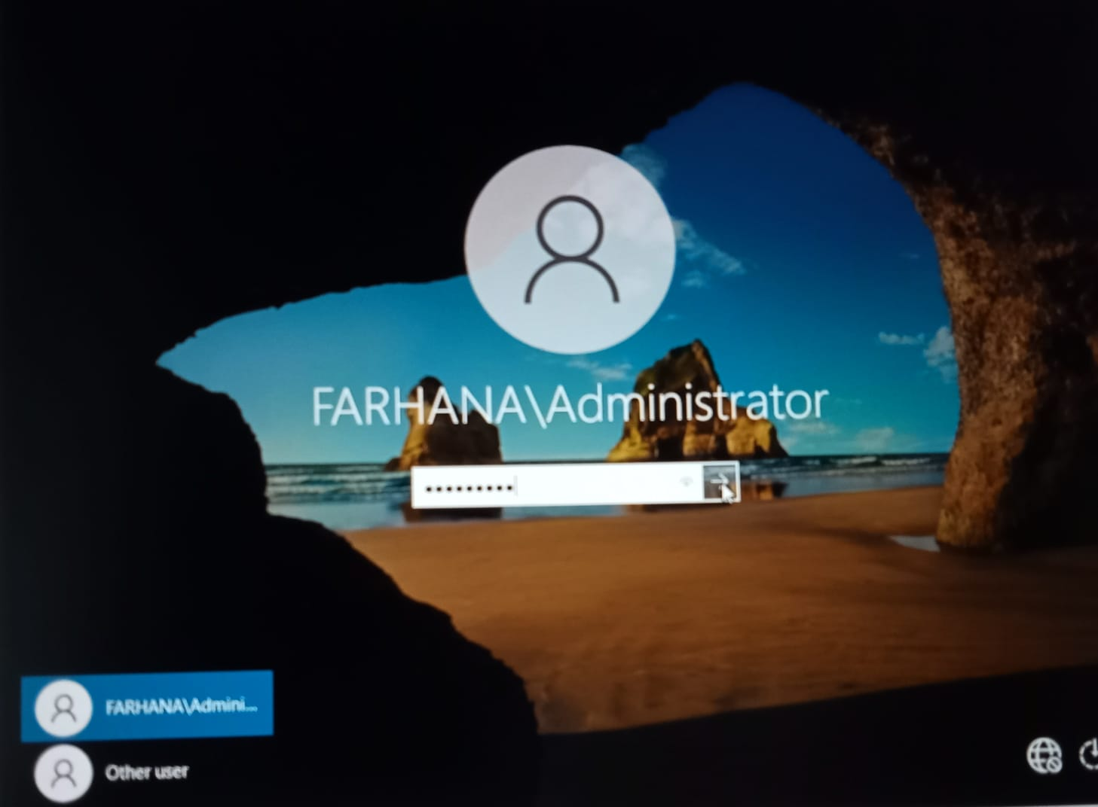

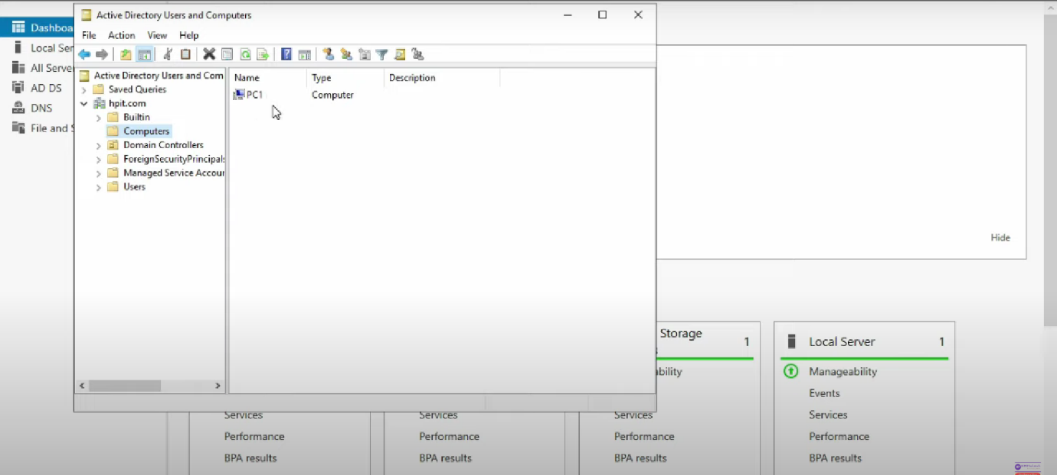In Command Prompt we can see: 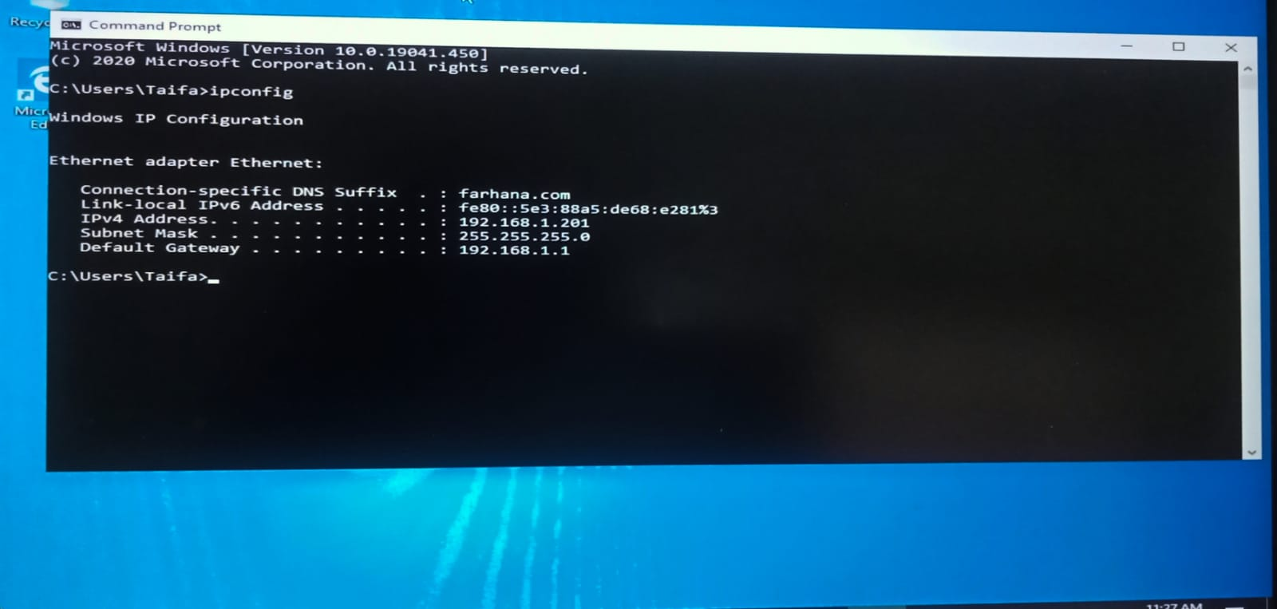

**Observations**

* The client systems were successfully joined to the domain, and domain users could log in using centralized credentials.

### ****Results****

The DHCP server dynamically assigned IP addresses to connected devices within the specified scope. The ADDS enabled centralized management of users and computers in the domain, while the DNS ensured seamless name resolution across the network.

**Discussion**

Integrating DHCP, ADDS, and DNS streamlines network management by automating IP allocation, centralizing authentication, and ensuring reliable hostname resolution. Proper configuration and regular monitoring are essential to prevent disruptions and maintain security.